Delivery Science Grants Program
Novel telehealth population care program led by clinical pharmacists boosts adherence, critical preventive care for members with severe mental illness
Lisa Fazzolari, DO & Esti Iturralde, PhD, Co-PIs, and Macy Shia, PharmD & Stacey Alexeeff, PhD, Co-Is
Challenge | Members with schizophrenia spectrum and bipolar disorder often disengage from psychiatric treatment and suffer high morbidity and mortality from preventable chronic health conditions.
Existing Evidence | Advanced practice clinical pharmacists have been well-integrated as care managers in population-based models for chronic disease management, but this approach is novel in psychiatry. It was previously unknown if patients with schizophrenia spectrum and bipolar disorder would engage via telehealth with clinical pharmacists for routine care.
Target Population | Adults with schizophrenia, schizoaffective disorder, and bipolar disorder
Intervention or Exposure | Enrollment in SPMI Population Care at 6 KPNC demonstration sites versus usual psychiatric care at 6 non-program sites
Outcomes/Key Findings | High program engagement and significant 1-year improvements on psychiatric medication adherence and other key preventive care (including HEDIS outcomes) were observed for Population Care versus Usual Care patients. Nearly 90% of enrolled Population Care patients attended a program intake and of these, 87% attended ≥ 1 follow-up visit. Among Population Care patients who lacked a recent psychiatrist visit, 87% were re-engaged in care by the program. Relative to Usual Care, the Population Care group had a 6-percentage-point increase in optimal psychotropic medication adherence, a 13-percentage-point increase in lipid screening, a 9-percentage-point increase in glycemic monitoring, and other preventive care improvements. Compared to Usual Care, Population Care patients also significantly reduced their psychiatrist visiting by 6 percentage-points (i.e., proportion with any annual visit) without worsening their mental health status (based on self-report and psychiatric utilization). Population Care patients also had relatively lower hospital use (all-cause and psychiatric), but these differences from Usual Care were not statistically significant.
Resulting Action/Change | SPMI Population Care is expanding. RWC and SFO Psychiatry will add the program in Fall of 2023.  The project informed needed process improvements to increase efficiency and impact. Specifically, patients have needed additional reminders to pick up medications and get labs done. We are developing a reminder protocol with Regional Outreach Strategy Center of Excellence (ROSCOE).
Additional Recommendations | - Program enhancements may help mitigate clinical pharmacist burnout and increase impact, such as case management services for patients with limited functioning.  - Development of a patient registry dashboard may increase program efficiency.  - Fidelity across sites should be monitored to maintain a standardized approach to assessment and care.  - Collect additional patient-reported outcomes more routinely; PHQ-9 and other commonly implemented measures do not capture the range of symptoms experienced by people with SPMI.
Implementation Tools | SPMI Population Care program clinicians and physician extenders to support patients across psychiatry.
Implementation Measurement | - Proportion of enrolled patients who attended initial intake appointments  - Proportion of patients without recent psychiatrist visit who were re-engaged in care  - Any follow-up visit after initial intake  - Follow-up visit rate per quarter
Reference | 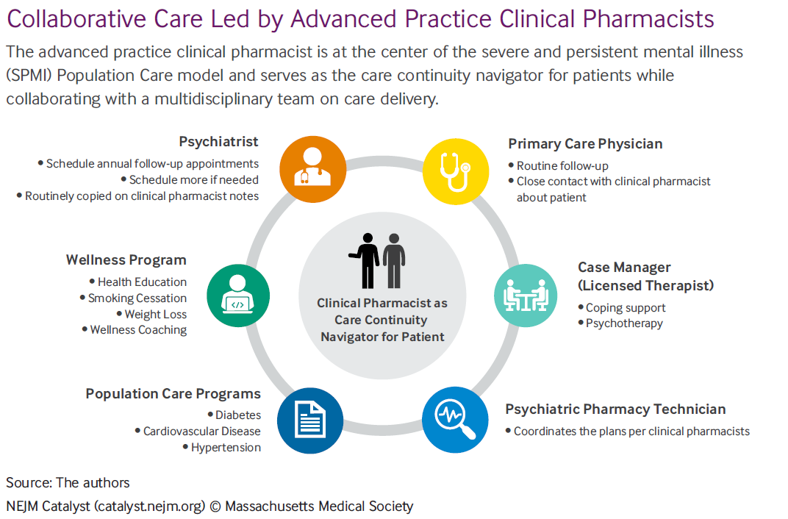  doi: 10.1056/CAT.21.0417
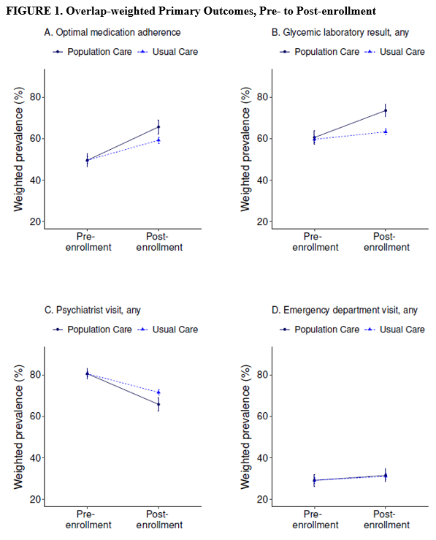
From Iturralde, Fazzolari, et al., under review

