Delivery Science Grants Program
Project Title: Post-acute sequelae of SARS-CoV-2 infection (PASC) in adult KPNC members

Investigators: Dustin W. Ballard, MD, MBE (PI); Mary E. Reed, DrPH (Co-PI); Jacek Skarbinski, MD; Edward Durant, MD; David R. Vinson, MD; Dustin Mark, MD; Marc Siqueiros, MD; Madhavi Cholleti, MD; and the KP CREST Network
Challenge | Research on Post-acute Sequelae of COVID (PASC) has focused on the prevalence of symptoms, leaving gaps in our understanding of predictors and impact of health care utilization.
Existing Evidence | At the time this project was initiated there was limited evidence about PASC including its prevalence, risk-factors and impact on utilization. Since then, the body of evidence has grown substantially, and the key findings of our Aims are consistent with this now extensive body of evidence.
Target Population | KPNC adult members with COVID including PASC, and a comparison group without PASC.
Intervention or Exposure | Health care utilization between patients with PASC care-seeking and patients without PASC care-seeking
Outcomes/Key Findings |  | PASC care utilization (care-seeking) prevalence in KPNC was less common than incidence of PASC described in other settings however was associated with stark and broad increases in healthcare utilization. Predictors of PASC care utilization, included higher illness severity, medical comorbidities, and infection during the COVID-19 Delta and pre-Delta periods.  Characteristics/predictors associated with PASC care- utilization Of 600,295 surviving COVID patients, 3,797 (0.63%) had eligible PASC care encounters. Female sex (RR 1.29, 95% CI 1.20 - 1.39), non-Hispanic white race, age 40 - 49 years (RR 2.35, 95% CI 2.08 - 2.66), more severe acute COVID illness, including an ED visit (RR 4.41, 95% CI 3.92 - 4.96), and severe depression (RR 1.69, 95% CI 1.32 - 2.16) were associated with PASC care utilization. COVID immunization (RR 0.79, 95% CI 0.72 - 0.85), metformin use among diabetic patients (RR 0.74, 95% CI 0.64 - 0.84), diagnosis during Omicron predominance (RR 0.54, 95% CI 0.49 - 0.60) were associated with less PASC care utilization.  Health Care utilization of PASC patients  PASC patients had significantly higher baseline and post-PASC-diagnosis utilization compared to non-PASC controls, in all utilization outcomes studied (Figures below), with more pronounced differences noted in specialty care testing and referrals for cardiac and pulmonary conditions.  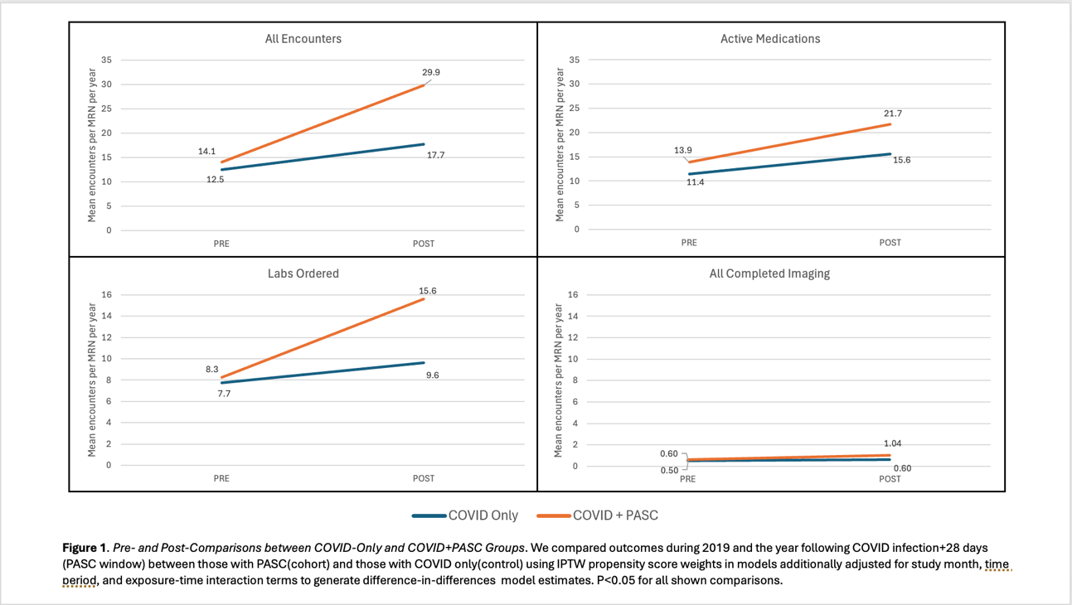  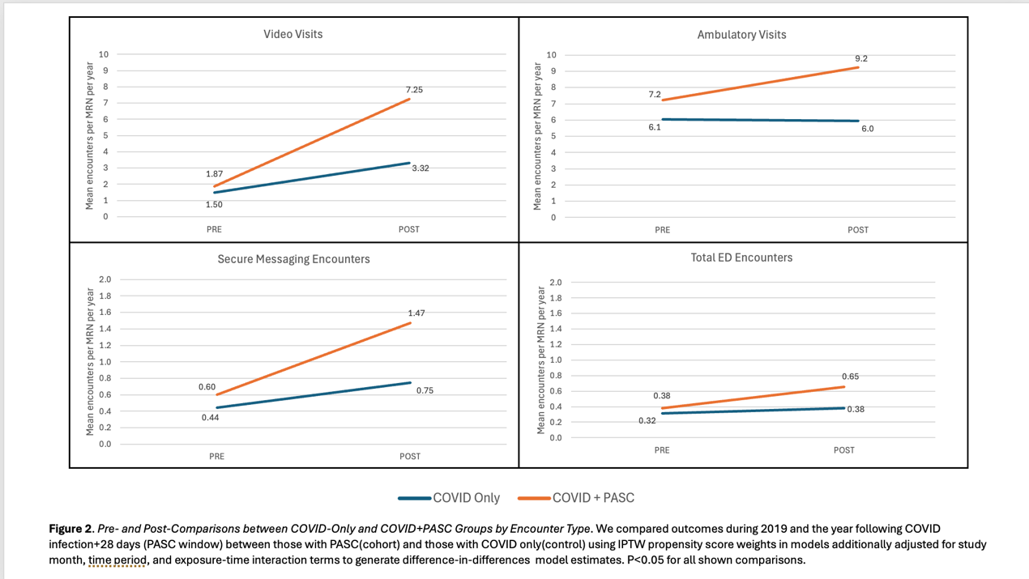  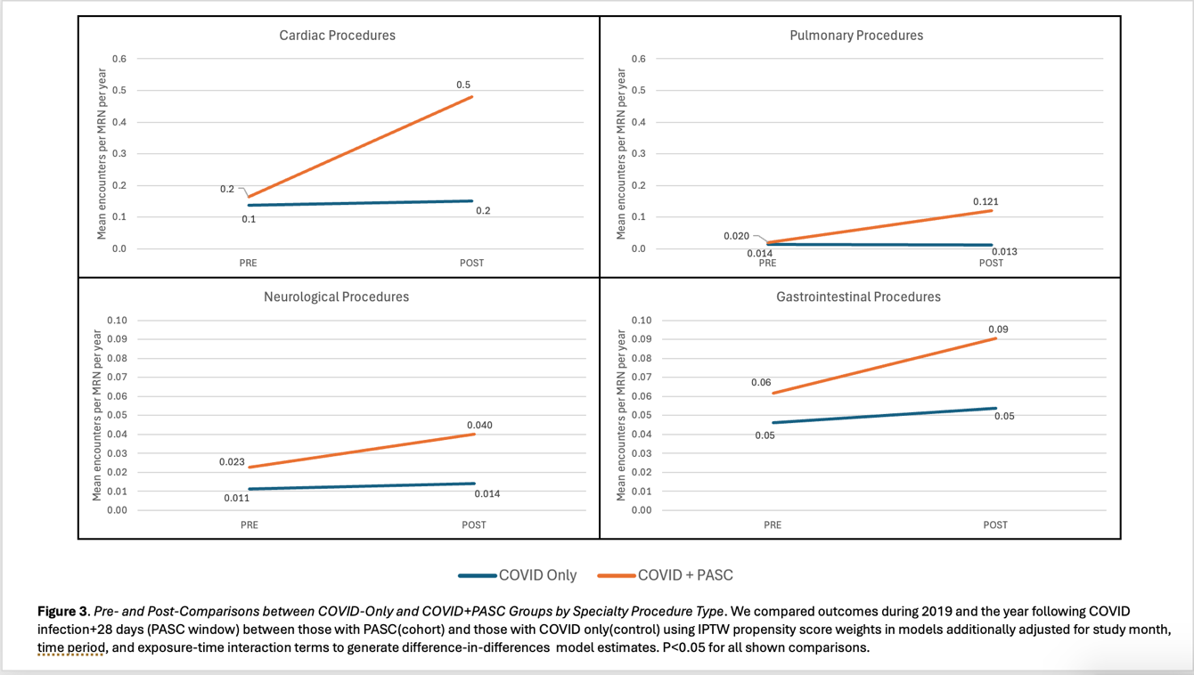
Resulting Action/Change | PASC clinical care leaders have focused on early diagnosis and capture/sorting of patients in order to maximize multidisciplinary interventions and mitigate long-term chronic health needs. Our work helped inform the refinement of the KPNC PASC clinical guidance document.
Additional Recommendations | Our results can serve as a case study for better organization of primary care for conditions such as PASC that are challenging to manage and resource-intensive. Future discussions with AFM leadership are pending to discuss how to actualize such clinical clusters of expertise within AFM.
Implementation Tools | Development of a cohort definition for PASC in KPNC
Implementation Measurement | Utilization codes have been organized by clinical domain and specialty and are available for use in tracking future trends in utilization amongst PASC patients or other populations.
Reference | https://onlinelibrary.wiley.com/doi/10.1111/joim.13760  Durant EJ, Warton M, Skarbinski J, Siqueiros MH, Cholleti SM, Vinson DR, Mark DG, DiLena DD, Rauchwerger AS, Reed ME, Ballard DW. Predictors of Health Care Utilization in Patients with Long COVID. Undergoing peer review.  Ballard DW, et al. The Long Tail of Long COVID: Characterizing PASC Associated Health Care Utilization. Submission pending.

