Improving Outcomes and Care Experience among Dual Eligible Members: The Role of Health System Factors
Banerjee, Somalee MD, MPH, Catherine Lee, PhD, Richard Grant, MD, MPH, Julie Schmittdiel, PhD, Lin Ma, MS, Alyce S. Adams, PhD
Challenge | The complex health and social needs of dual eligible members (e.g. Medi-cal and Medicare) puts them at higher risk for persistently high health care costs, but little is known about healthcare outcomes and modifiable drivers of these costs. KPNC is developing innovative interventions. The proposed study will be among the first to identify health system factors associated with care processes and outcomes among dual eligibles in a capitated health care system overall and across coverage subtypes.
Existing Evidence | At KPNC, dual eligibles represent only 4% of all newly enrolled Medicaid members, but account for more than 10% of high cost members. ¹ Fragmentation of health care services may impede care optimization; integrated care may improve value,² but results from various managed care plans are mixed, with likely variability of populations and interventions.^{3,4,5-11} Little evidence exists about health system level interventions might reduce low value, expensive utilization and improve care among dual eligibles.^{9,10}
Target Population | KPNC members who became newly dually eligible between 2016 and 2019, stratified by dual enrollment status: Special Needs Population (SNP) + Medicaid Managed Care (MCMC), SNP only, Medicare + MCMC, and Medicare Only (Figure 1).
Intervention or Exposure | Key exposures: dual enrollment status and health system level factors for utilization from prior research studies.  Primary outcome: readmission or admission to the hospital or emergency department (ED) for an ambulatory sensitive condition during the year following dual eligibility.  Methods: microsimulation to evaluate changing modifiable factors and Cox PH models (i.e., dual enrollment status, engagement in kp.org) on risk of the primary outcome.
Outcomes/Key Findings | Facilities varied in outcomes; the lowest region (Sacramento) had 30% lower risk of potentially avoidable ED and hospital use than the highest region (Redwood City). Models suggest enrolling dual eligible currently in Medicare Only or D-SNP Only into D-SNP plus Medicaid Managed care may markedly reduce risk (Figure 2).  There are significant differences in the baseline health, demographics and healthcare utilization between the dual eligible subgroups. [Table 1] :  Factors associated with lower risk (see also Table 2)  -older age (>50 years); enrollment in both D-SNP and Medicaid or in Medicare alone (versus D-SNP only); Asian race; discordant patient/provider language.  Factors associated with higher risk  -not using the patient portal [HR: 1.34; 95% Confidence Interval:(1.2, 1.5)]; multi-morbidity;  living in a lower socioeconomic status neighborhood
Resulting Action/Change | Work with the SNP group in the TPMG consulting group and the regional hospital resource management group to interpret findings and to identify potential avenues for intervention.
Additional Recommendations | Assessing reasons for variation in dual enrollment in D-SNP plus MCMC may be informative; evaluation of TPMG leadership awareness of findings and any recommendations for further study that would inform operations.
Implementation Tools | We will explore whether the simulation tool created as part of this project might be useful to TPMG in identifying potential intervention components.
Implementation Measurement | NA
Reference | Figure 1. Cohort building algorithm for the study  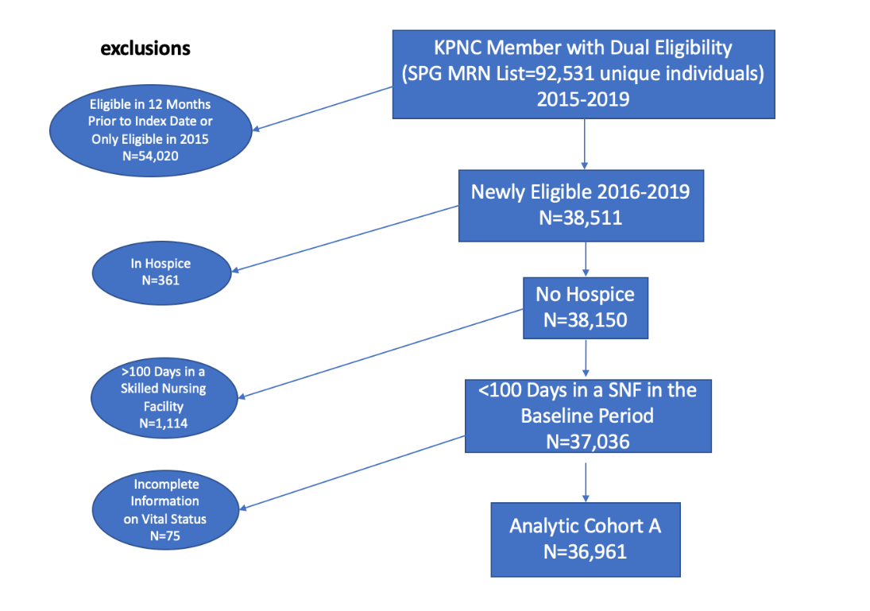  Figure 2. Microsimulation: Effect of switching coverage status for dual eligible on time to avoidable hospitalizations and ED visits  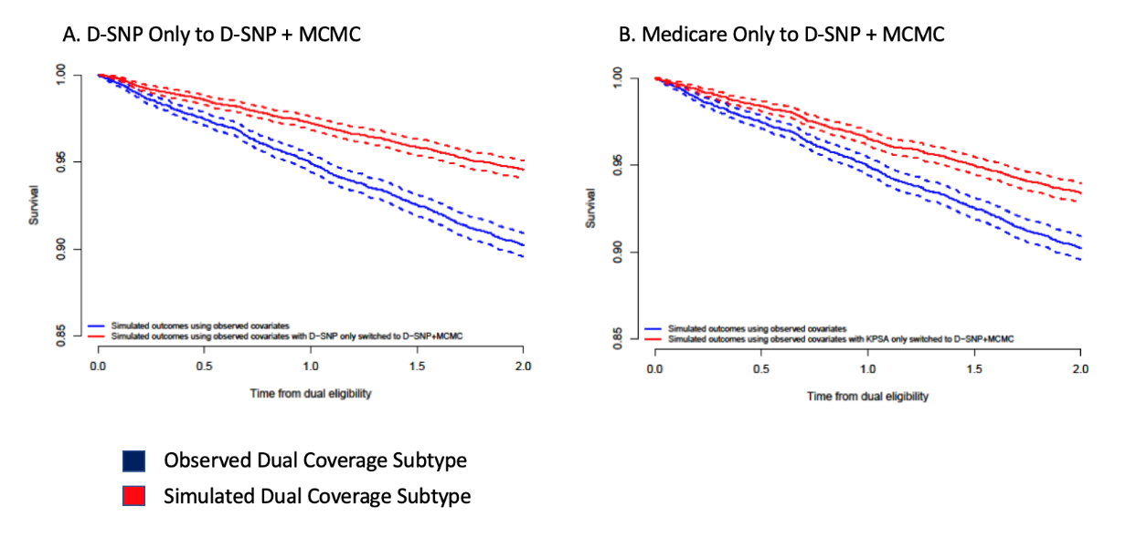  Table 1. Patient characteristics of the dual eligible population studied  Independent factor Level All (N=36,961)* n(%) D-SNP Only (N=13,941)* n(%) D-SNP+MCMC (N=2,011)* n(%) KPSA Only (N=11,916)* n(%) KPSA+MCMC /MCMC Only (N=9,093)* n(%) P Value  Patient Age on the Index Date Mean (SD) 64.69 (13.61) 64.46 (13.65) 61.09 (12.86) 69.32 (13.47) 59.78 (11.73) <0.0001*  Sex <0.0001*  FEMALE 21852 (59.12) 8166 (58.58) 1147 (57.04) 7349 (61.67) 5190 (57.08)  MALE 15107 (40.88) 5774 (41.42) 864 (42.96) 4567 (38.33) 3902 (42.92)  Race/Ethnicity <0.0001*  1.White 13821 (37.39) 4396 (31.53) 886 (44.06) 5023 (42.15) 3516 (38.67)  2.Asian 8167 (22.10) 3403 (24.41) 488 (24.27) 2238 (18.78) 2038 (22.41)  3.Black 4980 (13.47) 2054 (14.73) 214 (10.64) 1495 (12.55) 1217 (13.38)  4.Hispanic 7849 (21.24) 3144 (22.55) 330 (16.41) 2531 (21.24) 1844 (20.28)  5.Other 639 (1.73) 253 (1.81) 33 (1.64) 177 (1.49) 176 (1.94)  6.Unknown 1505 (4.07) 691 (4.96) 60 (2.98) 452 (3.79) 302 (3.32)  Standardized Neighborhood Deprivation Index Score Mean (SD) 0.24 (0.98) 0.39 (1.03) 0.15 (0.88) 0.15 (0.95) 0.16 (0.94) <0.0001*  Standardized Neighborhood Deprivation Index (quartiles) Q1 4912 (13.29) 1450 (10.40) 287 (14.27) 1814 (15.22) 1361 (14.97) <0.0001*  Q2 9490 (25.68) 3196 (22.93) 525 (26.11) 3333 (27.97) 2436 (26.79)  Q3 9964 (26.96) 3633 (26.06) 605 (30.08) 3184 (26.72) 2542 (27.96)  Q4 11843 (32.04) 5160 (37.01) 589 (29.29) 3377 (28.34) 2717 (29.88)  Unknown 752 (2.03) 502 (3.60) 5 (0.25) 208 (1.75) 37 (0.41)  Most Recent BMI Prior to the Index 1.Under/Normal 7327 (19.82) 1723 (12.36) 534 (26.55) 3022 (25.36) 2048 (22.52) <0.0001*  2.Overweight 7324 (19.82) 1693 (12.14) 525 (26.11) 2675 (22.45) 2431 (26.73)  3.Obese 8785 (23.77) 2047 (14.68) 727 (36.15) 2699 (22.65) 3312 (36.42)  4.Unknown 13525 (36.59) 8478 (60.81) 225 (11.19) 3520 (29.54) 1302 (14.32)  Baseline Smoking Status 1.None 12945 (35.02) 2957 (21.21) 839 (41.72) 4702 (39.46) 4447 (48.91) <0.0001*  2.Former 6829 (18.48) 1363 (9.78) 459 (22.82) 2675 (22.45) 2332 (25.65)  3.Current 2349 (6.36) 669 (4.80) 180 (8.95) 711 (5.97) 789 (8.68)  4.Unknown 14838 (40.15) 8952 (64.21) 533 (26.50) 3828 (32.12) 1525 (16.77)  Alcohol Consumption No 13112 (35.48) 2635 (18.90) 874 (43.46) 5012 (42.06) 4591 (50.49) <0.0001*  Yes 5066 (13.71) 941 (6.75) 358 (17.80) 1776 (14.90) 1991 (21.90)  Not applicable/Unknown 18783 (50.82) 10365 (74.35) 779 (38.74) 5128 (43.03) 2511 (27.61)  Doing any Exercise <0.0001*  No 11984 (32.42) 2632 (18.88) 818 (40.68) 4756 (39.91) 3778 (41.55)  Yes 10451 (28.28) 2350 (16.86) 972 (48.33) 3246 (27.24) 3883 (42.70)  Not applicable/Unknown 14526 (39.30) 8959 (64.26) 221 (10.99) 3914 (32.85) 1432 (15.75)  150 Minutes MVPA/Week No 17070 (46.18) 3731 (26.76) 1284 (63.85) 6390 (53.63) 5665 (62.30) <0.0001*  Yes 5290 (14.31) 1232 (8.84) 500 (24.86) 1590 (13.34) 1968 (21.64)  Not applicable/Unknown 14601 (39.50) 8978 (64.40) 227 (11.29) 3936 (33.03) 1460 (16.06)  Elixhauser Comorbidity Index Mean (SD) 4.94 (3.78) 4.68 (3.60) 4.68 (3.53) 5.56 (4.02) 4.57 (3.70) <0.0001*  Patient/provider race concordance No 19107 (51.70) 6442 (46.21) 1044 (51.91) 6580 (55.22) 5041 (55.44) <0.0001*  Yes 13717 (37.11) 5115 (36.69) 867 (43.11) 4151 (34.84) 3584 (39.41)  Not applicable/Unknown 4137 (11.19) 2384 (17.10) 100 (4.97) 1185 (9.94) 468 (5.15)  Patient-Physician Language Concordance No 5605 (15.16) 2726 (19.55) 247 (12.28) 1339 (11.24) 1293 (14.22) <0.0001*  Yes 31215 (84.45) 11151 (79.99) 1761 (87.57) 10518 (88.27) 7785 (85.62)  Not applicable/Unknown 141 (0.38) 64 (0.46) 3 (0.15) 59 (0.50) 15 (0.16)  Kp.org Registration No 16320 (44.15) 9005 (64.59) 450 (22.38) 4667 (39.17) 2198 (24.17) <0.0001*  Yes 20641 (55.85) 4936 (35.41) 1561 (77.62) 7249 (60.83) 6895 (75.83)  Kp.org Use at Baseline No 21928 (59.33) 10902 (78.20) 684 (34.01) 6710 (56.31) 3632 (39.94) <0.0001*  Yes 15033 (40.67) 3039 (21.80) 1327 (65.99) 5206 (43.69) 5461 (60.06)  # of Outpatient Visits Within 24 Months Before Index Date Mean (SD) 10.76 (18.14) 8.14 (14.91) 12.11 (18.96) 10.23 (17.16) 12.79 (20.55) <0.0001*  # of ED Visits Within 24 Months Before Index Date Mean (SD) 2.45 (2.73) 2.27 (2.58) 2.08 (1.90) 2.63 (2.83) 2.45 (2.86) <0.0001*  # of Inpatient Visits Within 24 Months Before Index Date Mean (SD) 1.74 (1.35) 1.57 (1.18) 1.62 (1.11) 1.81 (1.35) 1.75 (1.47) 0.0002  cms_risk_ Mean (SD) 1.27 (1.05) 1.13 (0.90) 1.12 (0.64) 1.46 (1.22) 1.38 (1.08) <0.0001*  Proximity to Primary KP Facility Mean (SD) 8.43 (53.18) 8.52 (56.24) 5.29 (6.20) 9.30 (57.86) 7.89 (47.68) 0.0117  Table 2. Results of Cox Proportional Hazards Models Estimating Time to Avoidable Hospitalizatio or ED Use During the 1st 12 Months Follow Dual Eligibility  Covariates Hazard Ratio (Adjusted) 95% Confidence Interval  Facility (ref=Central Valley)  Diablo 0.87 (0.7,1.08)  East Bay 0.81 (0.66,0.98)  Fresno 0.78 (0.62,0.97)  Greater San Francisco 0.74 (0.58,0.95)  Greater Southern Alameda 0.75 (0.6,0.93)  Marin / Sonoma 0.87 (0.68,1.11)  Napa / Solano 0.83 (0.66,1.05)  Redwood City 1 (0.58,1.73)  Roseville 0.71 (0.57,0.88)  Sacramento 0.69 (0.57,0.85)  San Jose 0.8 (0.58,1.11)  Santa Clara 0.75 (0.55,1.02)  South Sacramento 0.74 (0.6,0.9)  Age (ref=<50) Age:(50,65] 0.69 (0.6,0.8)  Age:(65,80] 0.58 (0.5,0.68)  Age:(80,106] 0.7 (0.58,0.84)  Dual Subtype (ref=D-SNP Only) Dual:D-SNP+MCMC 0.76 (0.6,0.96)  Dual:KPSA Only 0.82 (0.73,0.93)  Dual:KPSA+MCMC/MCMC Only 0.91 (0.79,1.06)  Race (ref=white) Race:Asian 0.73 (0.61,0.87)  Race:Black 1.05 (0.91,1.2)  Race:Latino 0.96 (0.84,1.1)  Race:Missing 1.08 (0.73,1.61)  Race:Other/Mixed 1.04 (0.75,1.43)  Elixhauser Comorbidity Score (ref=Quartile 1: lowest comorbidity) Elix:Q2:3-4 3.48 (2.73,4.45)  Elix:Q3:5-7 7.78 (6.06,9.99)  Elix:Q4:7-23 19.92 (15.82,25.07)  Elix:Miss 0 (0,Inf)  Neighborhood Deprivation Index (ref=Quartile 1: highest SES) NDI:Q2 1.28 (1.05,1.57)  NDI:Q3 1.41 (1.16,1.72)  NDI:Q4 1.53 (1.26,1.86)  NDI:Miss 1.43 (1.01,2.03)  KP.org Use (rer=yes) Kp_org:No 1.34 (1.2,1.5)  Race concordance between patient and physician (ref=yes) Race concord:No 1.07 (0.95,1.21)  Race concord: Missing 0.96 (0.78,1.19)  Language concordance between patient and physician (ref=yes) Lang concord:No 0.81 (0.68,0.96)  Lang concord: Missing 2.85 (0.71,11.49)  References:  - MedPAC. A Data Book: Health Care spending and the Medicare Program. Chapter 4. Dual Eligible Beneficiaries. http://www.medpac.gov/docs/default-source/data-book/jun18_databookentirereport_sec.pdf?sfvrsn=0. 2018.  - Ferris R, Blaum C, Kiwak E, et al. Perspectives of Patients, Clinicians, and Health System Leaders on Changes Needed to Improve the Health Care and Outcomes of Older Adults With Multiple Chronic Conditions. J Aging Health. 2018;30(5):778-799.  - Jung HY, Trivedi AN, Grabowski DC, Mor V. Integrated Medicare and Medicaid managed care and rehospitalization of dual eligibles. Am J Manag Care. 2015 Oct;21(10):711-7.  - Bennett KJ, Probst JC. Thirty-Day Readmission Rates Among Dual-Eligible Beneficiaries. J Rural Health. 2016;32(2):188-195.  - Block J. Dual-eligible dilemma. States test managed care, but critics question if approach is cost-effective. Mod Healthc. 2013;43(16):14.  - Grabowski DC, Joyce NR, McGuire TG, Frank RG. Passive Enrollment Of Dual-Eligible Beneficiaries Into Medicare And Medicaid Managed Care Has Not Met Expectations. Health Aff . 2017;36(5):846-854.  - Libersky J, Hedley Dodd A, Verghese S. National and state trends in enrollment and spending for dual eligibles under age 65 in Medicaid managed care. Disabil Health J. 2013;6(2):87-94.  - Zhang Y, Diana ML. Effects of Early Dual-Eligible Special Needs Plans on Health Expenditure. Health Serv Res. October 2017. doi:10.1111/1475-6773.12778  - Eggbeer B, Bowers K, Morris D. Dual-eligible reform: a step toward population health management. Healthc Financ Manage. 2013;67(4):90-94, 96.  - Gold MR, Jacobson GA, Garfield RL. There is little experience and limited data to support policy making on integrated care for dual eligibles. Health Aff . 2012;31(6):1176-1185.  - Graham CL, Liu P-J, Hollister BA, Kaye HS, Harrington C. Beneficiaries Respond To California’s Program To Integrate Medicare, Medicaid, And Long-Term Services. Health Aff. 2018;37(9):1432-1441.  - MedPAC. The June 2018 Report to Congress: Medicare and the Health Care Delivery System. Chapter 9. Managed
Author 1, degree, Author 2, degree, …
Challenge | BOLD text
Existing Evidence | Normal text
Target Population | Normal text
Intervention or Exposure | Normal text
Outcomes/Key Findings | BOLD summary sentence. Normal text supporting sentence(s), as needed.
Resulting Action/Change | BOLD text
Additional Recommendations | Normal text
Implementation Tools | Normal text
Implementation Measurement | Normal text
Reference | Figure, table, graphical abstract  doi:
In carrying out this project, what problems or barriers did you encounter? (50 words or less)

In your experience with this project, what was the most positive or constructive aspect? (50 words or less)

Dissemination -- did your project lead to a presentation, report or publication? | ☐ No, please describe barriers, if any.  ☐ Yes, please list.
Did you or others learn something else from your project? | ☐ Formed a new relationship  ☐ Learned that the right data aren’t currently available  ☐ Identified unanticipated barriers to improving clinical practice  ☐ Other learnings

