FIT testing increases detection of polyps/CRC among younger African Americans (45-50 years)
Theodore R. Levin, MD, Christopher D. Jensen, PhD, MPH, Neetu M. Chawla, PhD, Lori C. Sakoda, PhD, MPH, Jeffrey K. Lee, MD, MAS, Wei K. Zhao, MPH, Molly A. Landau, MPH, Ariel Herm, MPH, Eryn Eby, MPH, Charles P. Quesenberry,
PhD, Douglas A. Corley, MD, PhD
Challenge | African Americans have increased incidence of colorectal cancer (CRC) before age 50 years, lower CRC screening rates, later stage at diagnosis and poorer survival compared to other races, but no prospective data on screening younger populations exist.
Existing Evidence | Some guidelines recommend starting CRC screening before age 50 years for African Americans, but there are few data on screening uptake, yield and long-term benefits of different screening tests below age 50 in this population.
Target Population | African Americans age 45–50 years.
Intervention or Exposure | A pilot study-directed mailed fecal immunochemical test (FIT) screening outreach program to the target populations.
Outcomes/Key Findings | Among 10,232 African Americans ages 45-50 mailed a FIT, screening was successfully completed by 33.1% and abnormal results were comparable to those routinely screened ages >50. Among the 4% with positive test results, 85.3% completed a follow-up colonoscopy: 57.8% had any adenoma, 33.6% had an advanced adenoma (adenoma with advanced histology or polyp 10 mm), and 2.6% were diagnosed with CRC. African Americans in the early screening group were modestly more likely to have completed screening than previously unscreened African Americans, whites, and Hispanics 51–56 years old.
Resulting Action/Change | Results led to change in TPMG policy to start screening African Americans at age 45, including mailed FIT. PROMPT updates are in process.
Additional Recommendations | Operational leaders can consider repeat evaluation to assess response rates with repeated invitations (similar approaches currently used to increase responses for older patients).
Implementation Tools | Study outreach letter.
Implementation and Follow-up Measures | Percentage of screening uptake among African Americans age 45-50 in comparison to previously unscreened African Americans, whites, Hispanics and Asian/Pacific-Islanders 51-56 years old (implementation); changes in cancers/cancer stage/advanced polyps detected (effectiveness); changes in need for surgery/chemotherapy (utilization)
Reference | 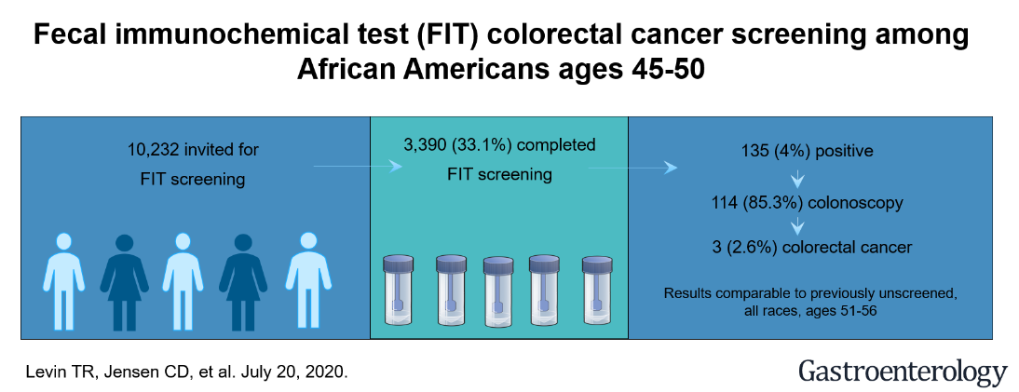  doi: 10.1053/j.gastro.2020.07.011  https://doi.org/10.1053/j.gastro.2020.07.011

