Short-course treatment (8 weeks) as effective as 12 weeks treatment for black patients with hepatitis C virus (HCV) infection

Julia L. Marcus, PhD, MPH; Leo B. Hurley, MPH; Scott Chamberland, PharmD; Jamila H. Champsi, MD; Laura C. Gittleman, RN, MBA; Daniel G. Korn, MD; Jennifer B. Lai, MSc, PharmD; Jennifer O. Lam, PhD, MPH; Mary Patricia Pauly, MD; Charles P. Quesenberry, Jr., PhD; Joanna Ready, MD; Varun Saxena, MD;

Suk Seo, MD; David J. Witt, MD; and Michael J. Silverberg, PhD, MPH
Challenge | Guidelines for hepatitis C treatment indicate that most people can be treated with ledipasvir and sofosbuvir for shorter durations (i.e., 8 weeks instead of the originally approved 12 weeks) but Black people with HCV were not included in this shorter recommendation based on data from older HCV treatments.
Existing Evidence | Prior observational studies suggested reduced response for black patients with hepatitis C receiving 8 weeks of therapy. However, because prior studies did not limit analyses to black patients otherwise eligible for 8 weeks (i.e., treatment-naive, no cirrhosis, HIV-uninfected, and HCV RNA <6 million IU/mL), black patients receiving 8 and 12 weeks may have differed with respect to key factors for treatment response.
Target Population | KPNC patients with HCV genotype 1 infection eligible for 8 week direct-acting antiviral regimen of ledipasvir/sofosbuvir
Intervention or Exposure | 8 or 12 week ledipasvir (LDV)/sofosbuvir (SOF)
Outcomes/Key Findings | Of 2653 patients eligible for 8 weeks of treatment with LDV/SOF, 1958 (73.8%) received 8 weeks of treatment and 695 (26.2%) received 12 weeks; the proportions of patients with sustained virologic response 12 weeks after the end of treatment (SVR12) were 96.3% for those given 8-weeks and 96.3% for those given 12 weeks of treatment (P = .94). Similarly, when stratified by race, there was no difference in SVR12 by regimen duration (see figure). Specifically, for Black people with HCV, the percentages with SVR12 for 8- and 12-week regimens were 95.6% vs 95.8%, respectively, with an adjusted relative risk of 1.0 (P = .88).
Resulting Action/Change | These findings changed national KP clinical practice to an 8-week course of direct-acting anti-hepatitis C treatment for eligible black patients (instead of 12-weeks). This decreased patient inconvenience, decreased cost by 1/3, and may decrease toxicity associated with longer durations of treatment. In 2019, new liver society guidelines cited this study and revised guidance to shorter regimens for Black people.
Additional recommendations | These results recommend evaluations for treatment differences/similarities for other medication regimens with conflicting data in the literature.
Implementation Tools | New KP and national liver society guidelines based on these results
Implementation and Follow-up Measures | Proportions of people with guideline concordant care, consistent with these findings: (e.g. 8 weeks for eligible patients); pharmacy utilization/cost; virologic response
Reference(s) [Key Figure if applicable] | SVR12 for HCV treatment of 8 vs. 12 weeks among 2653 HCV-infected individuals otherwise eligible for 8-week regimens  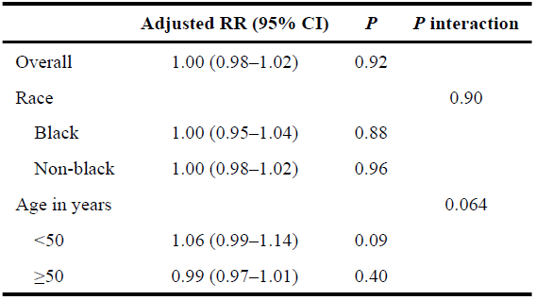  doi: 10.1016/j.cgh.2018.03.003. Epub 2018 Mar 11. https://pubmed.ncbi.nlm.nih.gov/29535057/

