Streamlining genetic counseling increases genetic testing among women with ovarian cancer

C. Bethan Powell, MD, Cecile Laurent, MS, Giuseppe Ciaravino, MD, Christine Garcia, MD, Liz Han, MD, Elizabeth Hoodfar, MS, LCGC, Audrey Karlea, MS, LCGC, Christine Kobelka, LCGC, Jaimie Lee, MD, Ramey D. Littell, MD,

Janise M. Roh, MSW, MPH, Agniezka Vay, MD, Lawrence H. Kushi, ScD

|  |  |
| --- | --- |
| Challenge | **The National Comprehensive Cancer Network and the KPNC Regional Genetics Department have established guidelines for referral for genetic risk assessment and genetic testing for women with ovarian cancer, yet it is estimated that only 10-15% of all women who meet eligibility for genetic testing at KPNC are identified, referred to genetic counseling, and complete testing.** |
| Existing Evidence | A model for streamlined genetic counseling and testing was developed and implemented in the United Kingdom whereby the oncology team routinely offered genetic testing to all ovarian cancer patients. Most patients with high-risk families are referred to genetic counselors, even those taken care of by relevant specialists, which may impede referral and, even if referred, completion of both counseling and testing. |
| Target Population | Women newly diagnosed with ovarian, fallopian tube, or peritoneal cancer. |
| Intervention or Exposure | Streamlined genetic education and testing process provided by gynecologic oncologists. |
| **Outcomes/Key Findings** | **The 40 women with ovarian cancer in the pilot were 50% more likely to receive streamlined genetic counseling from a gynecologic oncologist and complete genetic testing (100%) than women with standard pre-test counseling; had shorter ties** genetic testing (34 vs. 53 days from diagnosis); and patients, gynecologic oncologists, and genetic counselors were highly satisfied with the streamlined process. |
| **Resulting Action/Change** | **Streamlined genetic counseling and testing for ovarian cancer patients will be rolled out across all gynecologic oncology hubs in KPNC using processes and workflows developed to aid this process. Clinical implementation started Dec 17, 2020.** |
| Additional Recommendations | The streamlined genetic counseling and testing process may be evaluated for expansion to patients with breast cancer, certain gastrointestinal cancers, and other hereditary cancers. |
| Implementation Tools | Training presentation for gynecologic oncologists, checklist and key points document for clinicians, standardized order set, dot-phrase genetics note including family history questionnaire, patient FAQ document |
| Implementation Measurement | Uptake of genetic testing in KPNC for women with ovarian cancer, time from diagnosis to genetic test results. |
| Reference | Clinical implementation workflow: |

[**Streamlining** genetic testing for women with ovarian cancer in a Northern California health care system.](https://pubmed.ncbi.nlm.nih.gov/32778409/)

Powell CB, Laurent C, Ciaravino G, Garcia C, Han L, Hoodfar E, Karlea A, Kobelka C, Lee J, Littell RD, Roh J, Vay A, Kushi LH.Powell CB, et al. Gynecol Oncol. 2020 Oct;159(1):221-228. doi: 10.1016/j.ygyno.2020.07.027. Epub 2020 Aug 7.Gynecol Oncol. 2020. PMID: 32778409

Clinical workflow

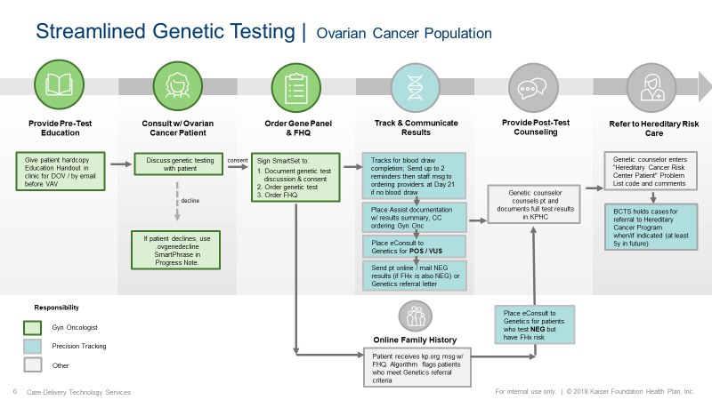

Publication

[**Streamlining** genetic testing for women with ovarian cancer in a Northern California health care system.](https://pubmed.ncbi.nlm.nih.gov/32778409/)

Powell CB, Laurent C, Ciaravino G, Garcia C, Han L, Hoodfar E, Karlea A, Kobelka C, Lee J, Littell RD, Roh J, Vay A, Kushi LH.Powell CB, et al. Gynecol Oncol. 2020 Oct;159(1):221-228. doi: 10.1016/j.ygyno.2020.07.027. Epub 2020 Aug 7.Gynecol Oncol. 2020. PMID: 32778409