New tool identifies diabetes patients at high risk of retinopathy and facilitates risk stratified screening
Dariusz Tarasewicz, MD, PhD (PI), Andrew Karter, PhD (Co-PI), Ronald B. Melles MD (Co-PI)
Challenge | Prioritize diabetic retinopathy screening based on clinical risk.
Existing Evidence | Current diabetic retinopathy screening in KPNC is based on Healthcare Effectiveness Data and Information Set (HEDIS) guidelines. Those with no known retinopathy are screened every two years. Those with known disease are screened yearly. At any given time, over 85% of patients screened by HEDIS guidelines show no or mild retinopathy and require no treatment. Prioritizing those at highest risk for visual complications based on a combination of clinical characteristics has the potential for creating greater efficiencies in the screening process.
Target Population | KPNC Diabetic Registry
Intervention or Exposure | Diabetic retinopathy screening
Outcomes/Key Findings | Risk calculator algorithms were built for 3 outcome measures (proliferative diabetic retinopathy, referable retinopathy, diabetic macular edema). A Health Connect version of proliferative diabetic retinopathy algorithm was constructed and will be implemented once code validation is complete. Risk score correlations for the 3 outcome measures have been done and may provide more opportunities for operational implementation and improved efficiency.
Resulting Action/Change | Improve safety and efficiency of diabetic retinopathy screening.
Additional Recommendations | Quality improvement and implementation studies are needed to evaluate whether and how this retinopathy risk stratification tool may influence provider behavior, screening and rates of diabetic eye disease. Health care delivery systems can use this model to allocate resources to improve outreach and compliance with the highest risk populations. Future research can identify optimal screening frequencies for lower risk populations yielding higher efficiency and safety for all.
Implementation Tools | Health Connect
Implementation Measurement | An impact study to evaluate the effects of implementing the model-based screening protocol is research that should be undertaken. However it is beyond the scope of this study and would require additional funded time
Reference | See below:  Sensitivity of logistic regression model compared to random screening  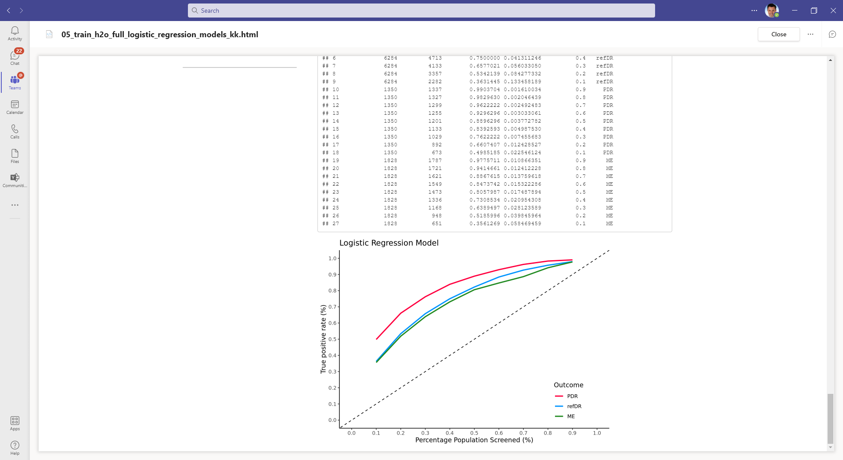  At all screening capacities, model -based approach outperforms random screening (diagonal line) for all three outcome measures. Abbreviations: PDR (proliferative diabetic retinopathy), refDR (referable retinopathy), ME (diabetic macular edema).
In carrying out this project, what problems or barriers did you encounter? (50 words or less) | Departure of data analyst Noel Pimentel to UC Berkeley graduate program in August 2021.  Departure of co-principal investigator, Oleg Sofrygin, to UBER in January 2022.
In your experience with this project, what was the most positive or constructive aspect? (50 words or less) | The project required significant collaboration between clinicians and DOR researchers. Once implementation steps were identified, an interdisciplinary group of stakeholders was assembled and rapid progress in Health Connect modeling was achieved.
Dissemination -- did your project lead to a presentation, report or publication? | ☐ No, please describe barriers, if any.  ☒ Yes, please list.  Manuscript entitled Development and Validation of a Diabetic Retinopathy Risk Stratification Algorithm was reviewed by Diabetes Care and manuscript revisions (based on reviewer comments) are in progress and will be resubmitted in Sept 2022.
Did you or others learn something else from your project? | ☒ Formed a new relationship  ☐ Learned that the right data aren’t currently available  ☐ Identified unanticipated barriers to improving clinical practice  ☐ Other learnings:

