New risk estimates for colon cancer among persons with serrated colon polyps inform guidelines for timing of repeat colonoscopy
Dan Li, Liyan Liu, Helene B. Fevrier, Stacey E. Alexeeff, Amanda R. Doherty, Menaka Raju, Laura B. Amsden, Jeffrey K. Lee, Theodore R. Levin, Douglas A. Corley and Lisa J. Herrinton
Challenge | Serrated colon polyps (SPs) are precursors to 20% to 30% of cases of colorectal cancer (CRC), but patients’ long-term risk after polyp removal is poorly understood, which may lead to inappropriate follow-up colonoscopy intervals. This study investigated the risk of CRC in individuals with a history of SPs.
Existing Evidence | Evidence around SPs and CRC risk is limited. Current surveillance guidelines suggest relatively frequent need for follow-up colonoscopy but the appropriateness relative to risk (and other polyp types) is unknown.
Target Population | Patients undergoing colonoscopy
Intervention or Exposure | Presence of serrated colon polyps
Outcomes/Key Findings | Among 233,393 individuals undergoing colonoscopy, 445 developed a subsequent CRC. 173,257 had no polyp on first colonoscopy; 11,505 had proximal SPs, 12,080 proximal SPs and synchronous adenomas, 19,410 distal SPs, and 17,141 distal SPs and synchronous adenomas. Among patients with SPs, risk of CRC was not increased until 3 years or more after the first colonoscopy (HR for small proximal SPs 2.6; 95% CI, 1.7–3.9 and HR for large proximal SPs 8.0; 95% CI, 3.6–16.1). The risk was higher if an adenoma was also diagnosed (HR for proximal SPs with synchronous adenomas 4.0; 95% CI, 3.0–5.5; and HR for distal SPs with synchronous adenomas 2.4; 95% CI, 1.7–3.4).
Resulting Action/Change | The study provided some of the first community-based evidence for post-colonoscopy risk stratification; this is influencing national and KP guidelines for follow-up colonoscopy surveillance after SP diagnosis (found on 1 of 10 colonoscopies).
Additional recommendations | Dissemination of findings to practitioner and follow-up analysis with compliance of these data into KPNC practices can inform evidence-based follow-up intervals.
Implementation Tools | Colonoscopy surveillance guidelines and risk measures
Implementation and follow-up measurements | Serrated polyp diagnosis and guideline-concordant follow-up (implementation); cancer risk after colonoscopy (effectiveness); changes in colonoscopy and cancer care (utilization)
Reference(s) [Key Figure if applicable] | 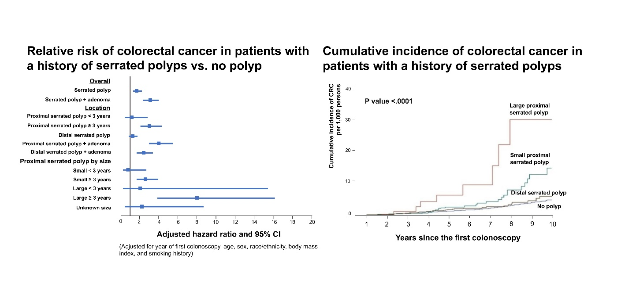  Doi: 10.1053/j.gastro.2020.04.004. PMID: 32277950  https://pubmed.ncbi.nlm.nih.gov/32277950/

