Decreased prostate cancer screening following the 2012 USPSTF Statement resulted in a significant increase in metastatic cancer and informs efforts for risk-stratified screening.
Joseph Presti Jr, Stacey Alexeeff, Brandon Horton, Stephanie Prausnitz, Andrew L Avins
Challenge | In 2012, the US Preventive Services Task Force (USPSTF) recommended against PSA-based screening for prostate cancer for all men. The impact of the resulting marked decrease in screening on clinical outcomes (including metastatic disease) are unknown and would inform whether more targeted screening may be advisable, such as for higher-risk groups (e.g. African-Americans).
Existing Evidence | PSA-based prostate cancer screening was suggested to be minimally effective for prostate cancer decreasing mortality in randomized trials. Thus, the USPSTF’s downgrading of PSA-based screening to “recommended against”, theoretically, this should have little impact on morbidity and deaths from prostate cancer, but little community-based data exist.
Target Population | Screen eligible men without a history of prostate cancer.
Intervention or Exposure | ”2012 USPSTF Statement stating “Do not screen anyone for prostate cancer”
Outcomes/Key Findings | After the USPSTF recommended against routine prostate cancer screening, screening rates declined 23.4% (95% CI 23.0-23.8%) and biopsy rates declined 64.3% (95% CI 62.9-65.6%). Subsequently, incident prostate cancer diagnoses declined 53.5% (95% CI 50.1-56.7%), resulting in 1871 fewer incident cancers detected, but metastatic cancer rates increased 36.9% (95% CI 9.5-71.0%) resulting in 75 more stage IV cancers detected.
Resulting Action/Change | The finding of more advanced cancers informs next-step already-started analyses for identifying the impact on high-risk populations (e.g. African Americans) who may benefit from more targeted prostate cancer screening, to lower the rate of metastatic cancer while minimizing over-screening of populations not likely to benefit (or to have harm).
Additional recommendations | These findings inform potential next steps such as outreach to higher risk groups for informed decision-making regarding screening and informing primary care about the consequences of not screening
Implementation Tools | Not applicable
Implementation and Follow-up Measures | Development of risk-stratified screening tools (implementation); changes in stage IV cancer (effectiveness); PSA testing, surgery, chemotherapy (utilization)
Reference(s) [Key Figure if applicable] | 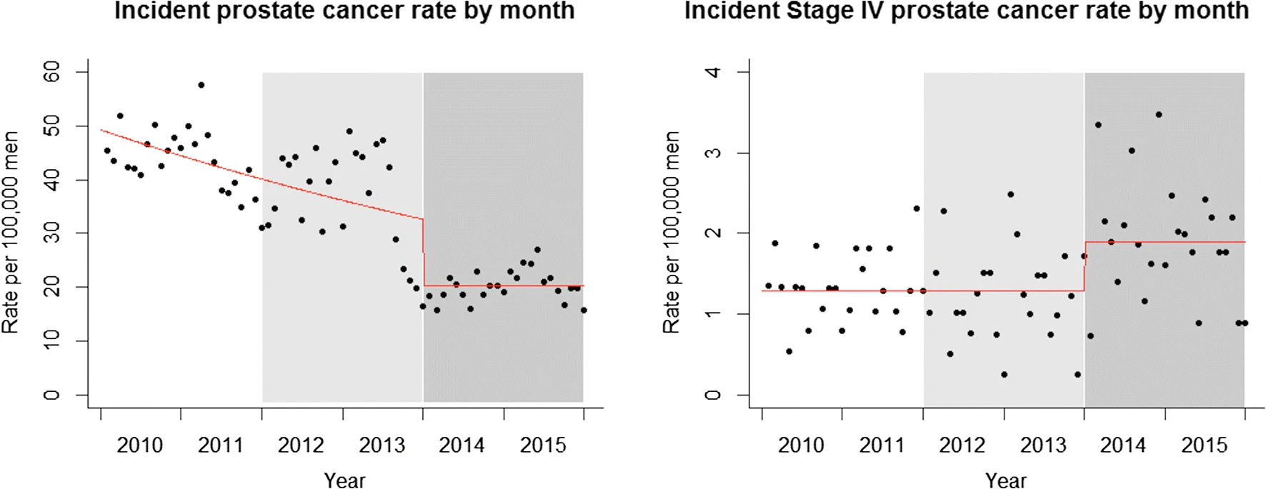  DOI: 10.1007/s11606-019-05561-y  https://link.springer.com/article/10.1007/s11606-019-05561-y

