A new streamlined surgical and perioperative-care approach results in meaningful benefits for patients undergoing esophagectomy for esophageal cancer
Simon K. Ashiku, M.D.; Ashish R. Patel, M.D.; Brandon H. Horton, M.P.H.; Jeffrey Velotta, M.D.; Sora Ely, M.D.; Andrew L. Avins, M.D., M.P.H.
Challenge | While a minimally invasive approach to esophagectomy for esophageal cancer has provided important advantages over conventional open procedures, there still remain important opportunities for further improvement in this widely practiced technique.
Existing Evidence | Recent data show that median hospital length of stay remains at approximately one week for minimally invasive esophagectomy (MIE). Median ICU length of stay, when reported, is typically between 1-3 days for both open and MIE procedures. Reported 30-day readmission rates are typically 9%-15%. Although MIE approaches have important advantages, reported complication rates remain in the range of 23% - 65%. Furthermore, transabdominal jejunostomy feeding tubes are generally placed for post-operative nutrition, potentially causing postoperative complications and delaying return-to-baseline functional status; routine feeding tube placement is described in most protocols and in three large series, >84% of patients were discharged home with feeding tubes.
Target Population | Patients with respectable esophageal cancer
Intervention or Exposure | A novel fully minimally invasive approach to the surgical procedure developed by Dr. Simon Ashiku (KPNC, Oakland), combined with a comprehensive perioperative patient-care program
Outcomes/Key Findings | This streamlined surgical and perioperative-care approach resulted in excellent clinical outcomes, including short hospital stays with limited need for the intensive care unit, few perioperative complications, and relatively few patients requiring feeding tubes on discharge. One hundred fifteen of 142 patients (81.0%) required no jejunostomy. Median hospital length-of-stay was 3 days and only 8 (5.6%) patients required admission to the intensive care unit. Postoperative complications occurred in 22 (15.5%) patients within 30 days of the procedure. There were no inpatient deaths; one patient (0.7%) died within 30 days following discharge and three additional deaths (2.1%) occurred through 90 days of follow-up.
Resulting Action/Change | The new approach examined is being disseminated to other thoracic surgeons in KPNC.
Additional Recommendations | None.
Implementation Tools | The publication resulting from this work will be disseminated throughout the KPNC thoracic surgery community, as well as to KPNC leadership.
Implementation Measurement | Uptake of this surgical approach throughout KPNC could be re-evaluated.
Reference | 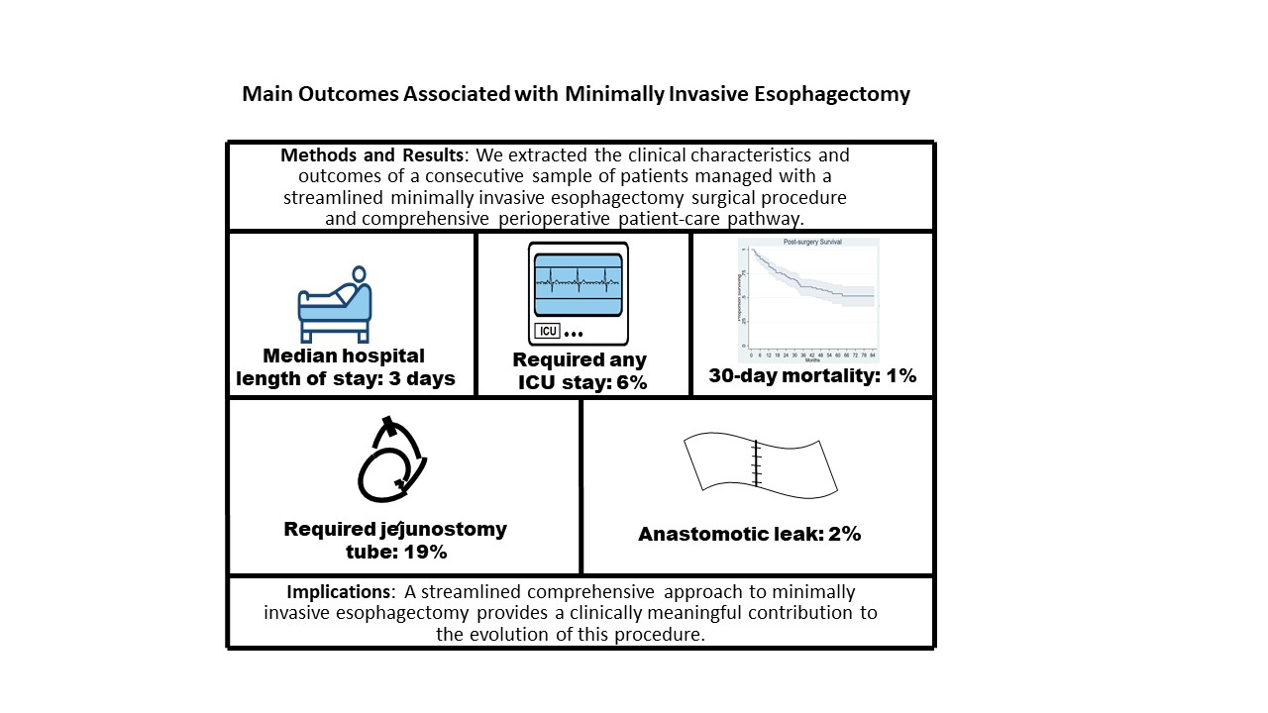  As of this writing, manuscript from this project is currently under journal review

