The KPNC StrokeExpress program markedly shortens time-to-thrombolysis for patients with ischemic stroke and provides important data for further studies to improve patient outcomes
Alexander C. Flint, MD, PhD, Mai N. Nguyen-Huynh, MD, MAS; Jeffrey G. Klingman, MD; Andrew L. Avins, MD, MPH; Vivek A Rao, MD; Abigail Eaton, PhD; Sunil Bhopale, MD; Anne C. Kim, MD; John W Morehouse, MD; Stephen Uong, MPH; Sean P Cullen, MD; Daniel P Hsu, MD; Nancy J Edwards, MD; Prasad A Reddy, MD; Sheila L Chan, MD; Patricia A Zrilak, RN, PhD
Challenge | 1) Reducing the "door-to-needle" (DTN) time for administering thrombolytic therapy to patients having an acute ischemic stroke is a critical determinant of outcomes for which KPNC has created a unique telestroke workflow (StrokeExpress); measuring the performance of this program has not been undertaken to date.  2) Endovascular stroke treatment (EST) is a relatively new option for patients with acute ischemic stroke but whether prior intravenous thrombolytic therapy may reduce its effectiveness (by causing distal migration of the cerebral-artery thrombosis) is unknown; KPNC's data may provide important evidence regarding this possibility.
Existing Evidence | 1) The most notable prior attempt at reducing door-to-needle time was the Helsinki model (Meretoja A, et al. Neurology. 2012. 24;79(4):306), which did not include a telestroke component. The incremental value of adding the telestroke intervention to the Helsinki model is unknown.  2) No high-quality studies have previously examined the issue of whether pre-treatment with intravenous thrombolytic therapy may reduce the likelihood of successful EST by causing distal embolization.
Target Population | 1) Patients with acute ischemic stroke  2) Patients with acute ischemic large-artery stroke
Intervention or Exposure | 1) StrokeExpress protocol to streamline workflows for administering intravenous thrombolytic therapy  2) Intravenous thrombolytic therapy before EST
Outcomes/Key Findings | 1) Introduction of the StrokeExpress protocol within KPNC using telestroke management was associated with increased alteplase administrations, significantly shorter DTN times, and no increase in adverse outcomes. After implementation, alteplase administrations increased 82% (P<0.001) and median DTN time decreased by 36% (P<0.001). DTN time <60 minutes was achieved in 87% versus 61% (P<0.001) of patients in the pre-StrokeExpress period and DTN times <30 minutes were much more common in the StrokeExpress period (40.8% versus 4.2% before implementation). There was no significant difference in symptomatic intracranial hemorrhage rates in the 2 periods (3.8% versus 2.2% before implementation; P=0.29).  2) Intravenous tPA administration before EST for large artery occlusion is associated with distal embolization, which may reduce the chance that EST can be attempted and recanalization achieved. Distal embolization before EST was quite common (20.1%) and occurred more often after intravenous tPA before EST (24.9%) than among those not receiving tPA (7.1%; P<0.001). Distal embolization was associated with an inability to attempt EST.
Resulting Action/Change | 1) The analysis confirmed the value of StrokeExpress program as standard of care for KPNC for the management of patients with symptoms and signs consistent with an acute stroke.
Additional Recommendations | 1) Formal change in acute stroke-management protocols await the results of multicenter randomized studies in progress.  2) Additional evaluations could explore why/which patients are not meeting current targets and potential modifiable factors.
Implementation Tools | 1) The performance of the StrokeExpress program continues to be monitored within KPNC  2) The role of primary EST in the management of patients presenting and signs and symptoms of an acute stroke are currently under discussion.
Implementation Measurement | 1) Changes in door-to-needle time are monitored regularly, allowing for corrections to existing protocols to maintain the benefits of the program  2) No formal measurement system
References | 1) 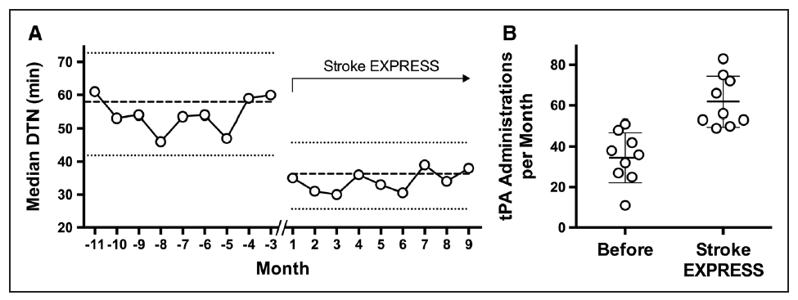  Ref: Nguyen-Huynh MN, Klingman JG, Avins AL, Rao VA, Eaton A, Bhopale S, Kim AC, Morehouse JW, Flint AC; KPNC Stroke FORCE Team. Novel Telestroke Program Improves Thrombolysis for Acute Stroke Across 21 Hospitals of an Integrated Healthcare System. Stroke. 2018 Jan;49(1):133-139. doi: 10.1161/STROKEAHA.117.018413.  2)  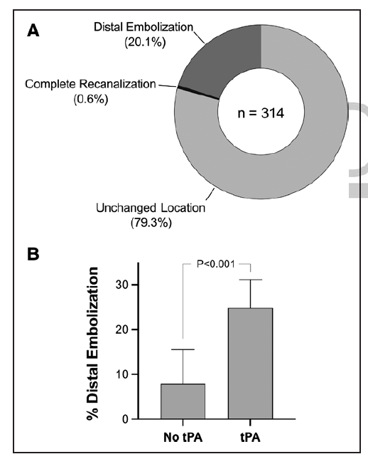  Ref: Flint AC, Avins AL, Eaton A, Uong S, Cullen SP, Hsu DP, Edwards NJ, Reddy PA, Klingman JG, Rao VA, Chan SL, Hartman J, Zrelak PA, Nguyen-Huynh MN. Risk of Distal Embolization From tPA (Tissue-Type Plasminogen Activator) Administration Prior to Endovascular Stroke Treatment. Stroke. 2020 Sep;51(9):2697-2704. doi: 10.1161/STROKEAHA.120.029025.

