Regionalizing sub-specialized adrenal surgery decreases operative time, hospital stay, and major complications

Reza Rahbari, MD, Mubarika Alavi, MS, Lisa J. Herrinton, PhD
Challenge | KPNC developed 6 centers of excellence for adrenal surgery, to consolidate surgery for the annual caseload of about 160 patients. This evaluation assessed the extent to which regionalization improved outcomes and sought to identify gaps in care that could be improved.
Existing Evidence | A recent systematic review (PMID 31331729) concluded that surgeons who perform >6 adrenalectomies per year have fewer complications and lower costs compared with lower volume surgeons. However, studies were based on hospital discharge databases and the National Inpatient Sample, which have limited data, lack long-term follow-up, and miss care provided in outpatient settings.
Target Population | Adult patients receiving adrenalectomy, 2010-2019, which include time periods before and after the start of regionalization in 2017. We excluded patients in which the adrenal gland was removed as part of a larger surgery.
Intervention or Exposure | Regional consolidation in 2017.
Outcomes/Key Findings | Average annual surgeon volume increased from 2.4 to 9.9 (p<0.001), while hospital volume increased from 3.5 to 15.4 (p<0.001). Operative time was 34 (p<0.001) minutes faster post-regionalization, and same-day discharges increased to 64% in 2019 (p<.0001). The frequency of return-to-care (p=0.69) and the overall complication rate (p=0.31) did not change.
Resulting Action/Change | The study provides evidence that regionalization and increased subspecialization of surgical care is effective and should be considered for other surgeries. Specific improvements are as follows:  - The rate of same-day discharge increasing steadily and likely will plateau at 80-90%.  - Through the RAU evaluation, we determined that the volume of adrenal surgery cases increased. A monitoring system implemented as part of the consolidation allowed for systematic review of cases. The increase was due not to benign or non-hormonally-active cases (incidentalomas), but to cases for which surgery was essential. Indeed, the fraction of excised incidentalomas that were cancerous was similar to national estimates, suggesting appropriate patient selection. Although not easily measured, we believe that the systematic review of cases allowed for earlier diagnosis of adrenal disease with earlier intervention. Also, complex patients were diagnosed earlier and provided with options while options were still available.  - Process review of outside referrals was implemented toward the goal of decreasing attrition of difficult cases to Stanford and UCSF. The system also enabled improved relationships with those institutions for obtaining collegial second opinions with surgeon-to-surgeon discussion.  - Finally, the updated credentialing redesign being built out across Northern California separates Adrenal Surgery from General Surgery bundle. Similar to bariatric surgery, it will have its own section.
Additional Recommendations | For other surgeries that could be consolidated, we recommend consideration of (1) executive sponsorship and physician championship, (2) need for coordination with other specialties such as radiology, endocrinology, pathology and oncology, (3) root cause analysis, (4) scoping of specific care pathways to be standardized included tools, staffing, and needed technology, and finally, (5) final determination of whether consolidation is realistic and high-priority.
Implementation Tools | - A physician champion was identified to lead development and implementation.  - Departmental leaders from each hospital agreed to support consolidation and to work with their surgery departments toward implementation.  - Surgeons interested in becoming adrenal sub-specialists were identified and evaluated.  Fellowship-trained surgeons with existing high volumes were selected and geographically mapped to assess patient travel time. Additional surgeons were identified at other centers to optimize patient travel. All surgeons committed to specialization.  - A sub-specialist adrenal surgeon was assigned to each of the health plan’s 21 endocrinology departments to improve communication and provide liaison.  - A monitoring system was instituted, allowing the early identification of any patient who was scheduled for adrenal surgery with a surgeon other than an adrenal sub-specialist so that the patient could be re-assigned to a sub-specialist.  - Quarterly reporting was instituted, for each surgeon and hospital, of their panels’ diagnosis, surgical approach, and operative time, enabling the transfer of best practices from high-performing to low-performing hospitals.  - The sub-specialist adrenal surgeons hold quarterly meetings with ongoing agenda, during which new practice guidelines and other evidence is discussed in the context of any needed process improvement. Surgeons share knowledge and increase standardization of surgical approaches and perioperative care pathways.  - Two multidisciplinary case conferences were introduced: one for endocrine cases that included specialists in endocrinology, pathology, and radiology, and one for cancer cases that also included oncologists. These conferences have been particularly important for complex patients.  - Every adrenalectomy is performed by two adrenal surgeons who double-scrub, further increasing surgical volume. This could be considered for other surgeries as well.
Implementation Measurement | Generalization to other surgical procedures, including the 5 specific steps identified under “Additional Recommendations”.
Reference | 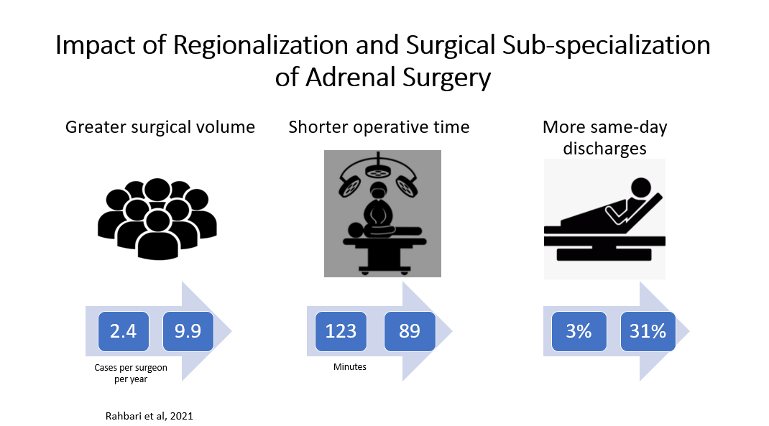  J:/RAU/RAU Visual Abstracts

