Benefits of Hepatitis C Virus Cure

Varun Saxena, MD MAS; Weilu Wu; Sreepriya Balasubramanian, MD MPH; Suk I. Seo, MD; Joanna B. Ready, MD; Brock A. MacDonald, MD; Nizar Mukhtar, MD; Julie A. Schmittdiel, PhD, MAS

|  |  |
| --- | --- |
| Challenge | **Studies have demonstrated decreased rates of cirrhosis, decompensation, hepatocellular carcinoma (HCC) and mortality after cure of hepatitis C virus (HCV), resulting in reduced healthcare burden. However, there is a lack of data identifying individuals whose risk of poor outcomes approaches that of the general, HCV negative, population and who can therefore be safely discharged from specialty clinics and HCC surveillance programs.** |
| Existing Evidence | Numerous studies have demonstrated that HCV cure results in significant decreases in the risk of cirrhosis, decompensation, HCC and mortality. However, poor outcomes continue to occur at a rate higher than those who never had HCV requiring ongoing specialty clinic care and HCC surveillance. Thus, the American Association for the Study of Liver Diseases (AASLD) currently recommends indefinite HCC surveillance after HCV cure despite significant reduction of risk. |
| Target Population | All adults (≥18 years) with HCV cure |
| Intervention or Exposure | Development of risk scores that identify patients with HCV cure whose risk of cirrhosis, decompensation, HCC and mortality approaches those of the general, HCV negative, population would inform who can safely stop specialty care and HCC surveillance programs. |
| **Outcomes/Key Findings** | Uncured HCV (n=21,184), HCV cured (n=11,950) and matched controls (99,402) were followed for development of cirrhosis, decompensation, HCC and mortality, some for >10 years. **Comparing uncured HCV vs. HCV cured vs. matched controls, rates of cirrhosis (18.4% vs. 4.1% vs. 1.1%), decompensation (10.8% vs. 2.8% vs. 0.9%), HCC (4.1% vs. 2.6% vs. 0.1%) and mortality (16% vs. 3.9% vs. 3.5%) were consistently lower among cured patients but did not reach that of controls.** Cox-regression modeling is currently underway to develop risk scores to identify both those HCV cured patients whose risk of poor outcomes approaches that of controls as well as to identify those HCV cured patients whose risk remains similar to uncured HCV patients. |
| **Resulting Action/Change** | **The results can inform TPMG policy as to who among HCV cured patients can safely be discharged from specialty clinics and HCC surveillance programs AND who may need even closer monitoring.** |
| Additional Recommendations | Operational leaders can consider incorporating risk scores into clinical toolbars or other handy, visible and accessible ways so as policy results can be implemented at the time of clinical care. These results also recommend evaluation of similar variations in treatment approach for other conditions with post-treatment risk-reduction. |
| Implementation Tools | Risk score calculators |
| Implementation Measurement | Review of gastroenterology and hepatology clinic visits done for HCV cured patients before and after risk scores available. Review of HCC surveillance performed on HCV cured patients before and after risk scores available. |
| Reference | **From DDW Abstract Submissions (some data above was updated after tables/figures made)**  Table 1: Baseline (i.e. at Cohort Entry) Characteristics of Chronic HCV, HCV Cure and Control Groups.  Figure 1: Cumulative Incidence of Cirrhosis, Decompensated Cirrhosis and All-Cause Mortality by Group  Figure 2: Cumulative Incidence of HCC by Group |

Table 1:

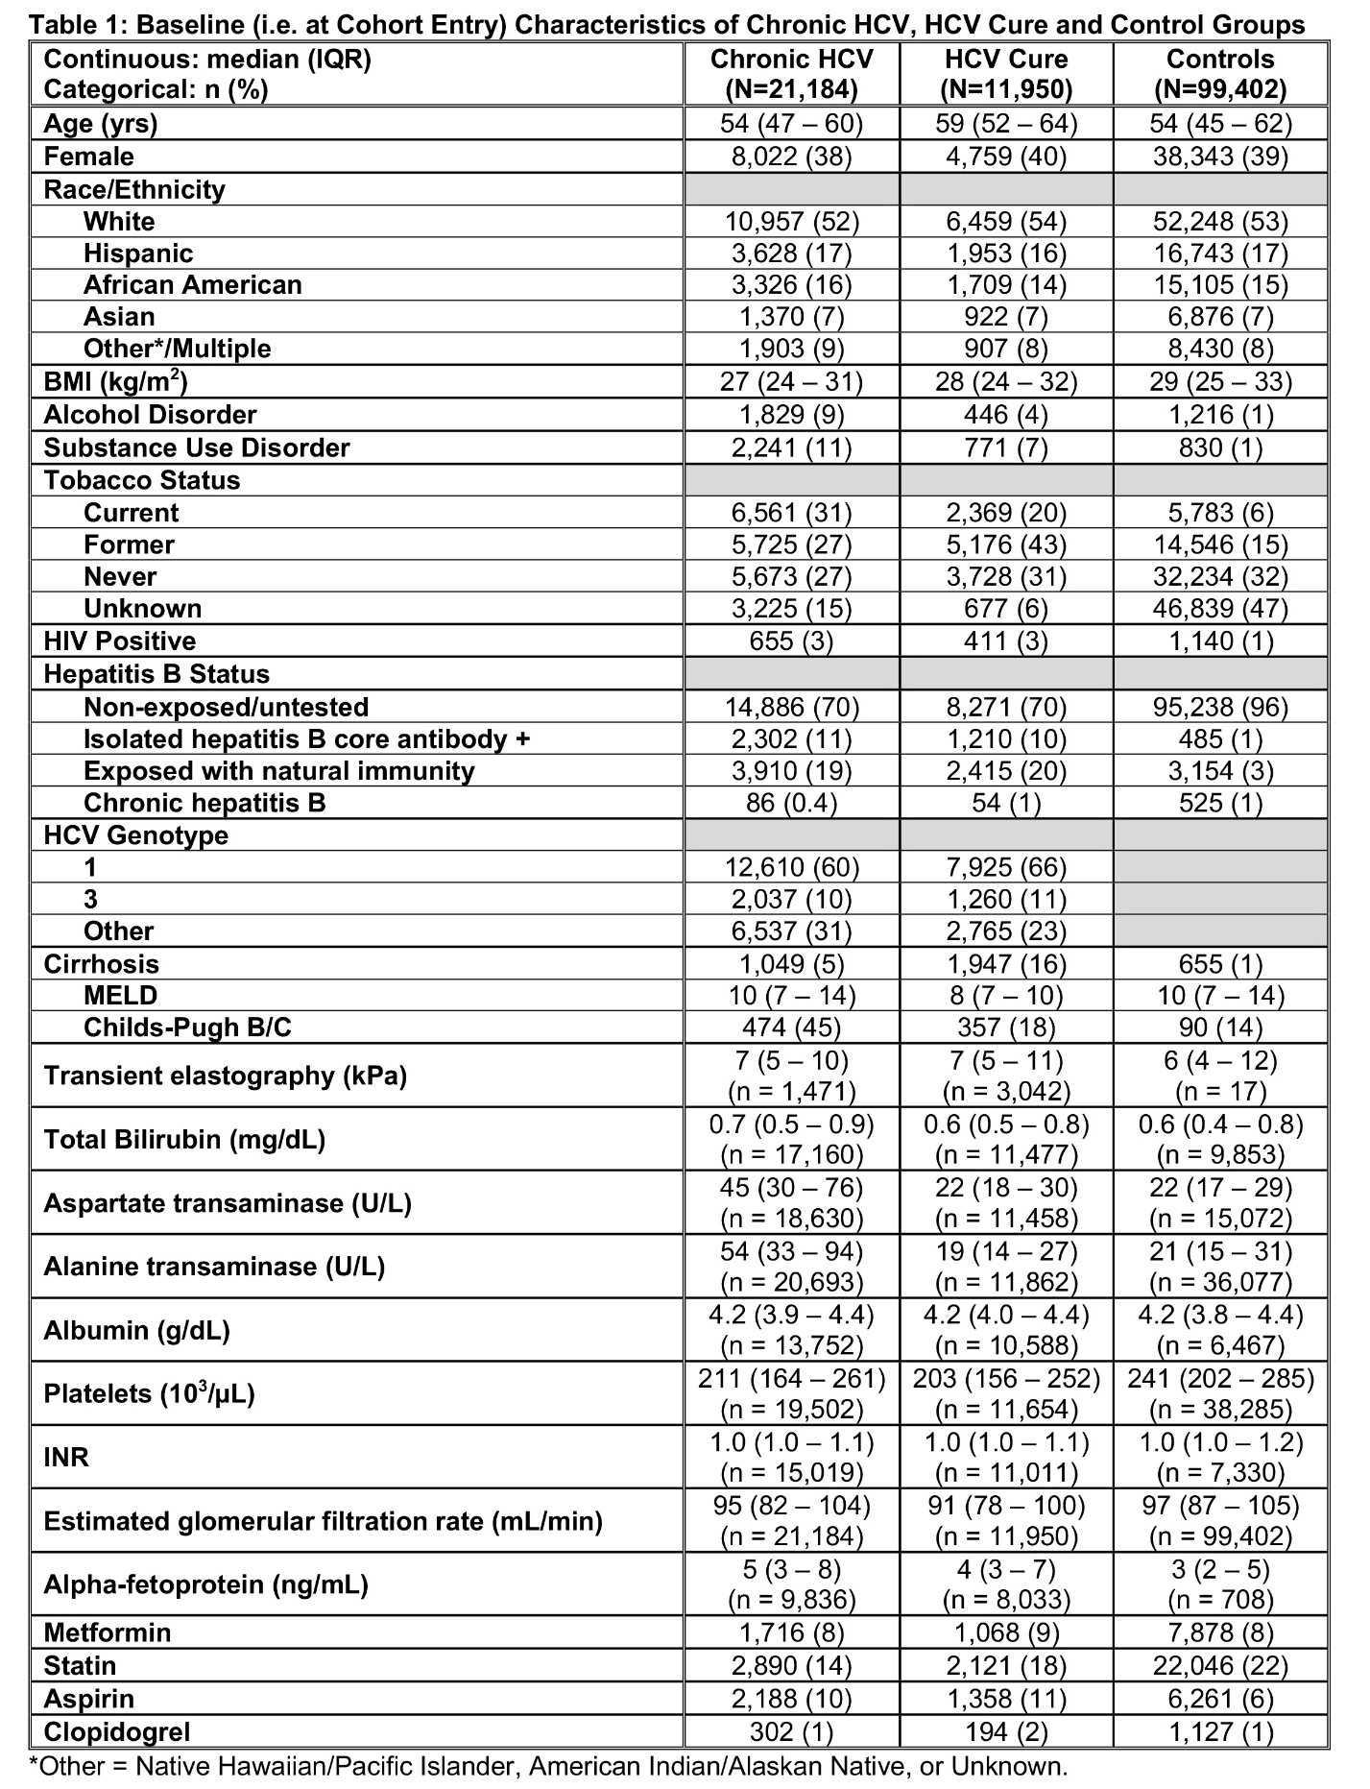

Figure 1:

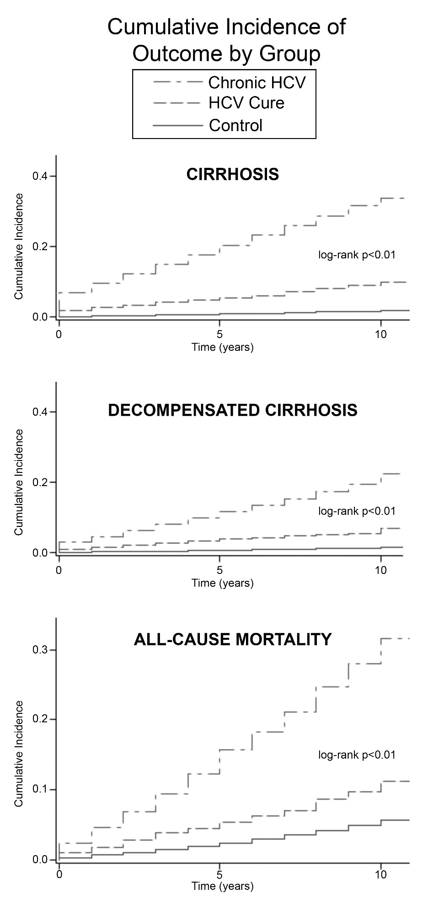

Figure 2:

