A systematic surveillance program improves care for patients with chronic Hepatitis B
Krisna P. Chai, M.D., Varun Saxena, M.D., M.A.S., Suk Seo, M.D., Brandon H. Horton, M.P.H., Andrew L. Avins, M.D., M.P.H., Mai Sedki, M.D., Joanna B Ready, M.D.
Challenge | Assess the performance and effectiveness of a dedicated surveillance program for patients with chronic Hepatitis B in Kaiser Permanente Northern California.
Existing Evidence | While surveillance for patients with chronic Hepatitis B is recommended by all official-society guidelines, there are few published descriptions of organized, systematic surveillance programs for patients with chronic Hepatitis B in the U.S., despite the wide availability of technology to support such efforts.
Target Population | KPNC members with documented chronic Hepatitis B (defined as ≥2 laboratory-test results of either hepatitis B surface antigen positivity and/or detectable hepatitis B viral load by DNA PCR at least 6 months apart)
Intervention or Exposure | The KPNC Liver Care Program (in which patients receive reminders to obtain semiannual laboratory and imaging surveillance, which are reviewed by nurse practitioners; treatment-eligible patients are provided antiviral medications)
Outcomes/Key Findings | A structured approach to chronic Hepatitis B surveillance was feasible on a large scale within KPNC and was associated with improvement in several measures of high-quality care for patients with chronic Hepatitis B.  Compared to patients not managed in the Liver Care Program, patients followed in the program were 3.8 times more likely to achieve 80% adherence with recommended hepatocellular carcinoma-surveillance imaging and approximately 4.5 times more likely to be screened with AFP according to published guidelines. Of all KPNC patients with chronic Hepatitis B, 1,264 met criteria for antiviral therapy and the large majority (72%) were enrolled in the Liver Care Program.
Resulting Action/Change | The Liver Care Program, as currently structured, provides clinically meaningful improvements in the long-term management for patients with chronic Hepatitis B; no potential major changes in the program processes were discovered during this work.
Additional Recommendations | None
Implementation Tools | Continued maintenance of the program’s processes
Implementation Measurement | The main analyses developed for the KPNC Liver Care Program could be repeated in 2-4 years to assess whether the currently observed rates of successful patient management are sustained over a longer period.
Reference | Manuscript under review.

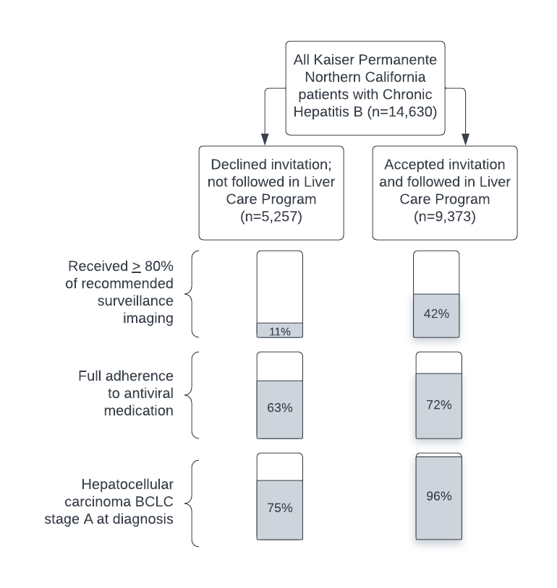

Figure 1. Kaplan-Meier survival curves for all-cause mortality among patients followed in the Kaiser Permanente Northern California Liver Care Program (red line) compared to eligible patients not followed in the program (blue line).

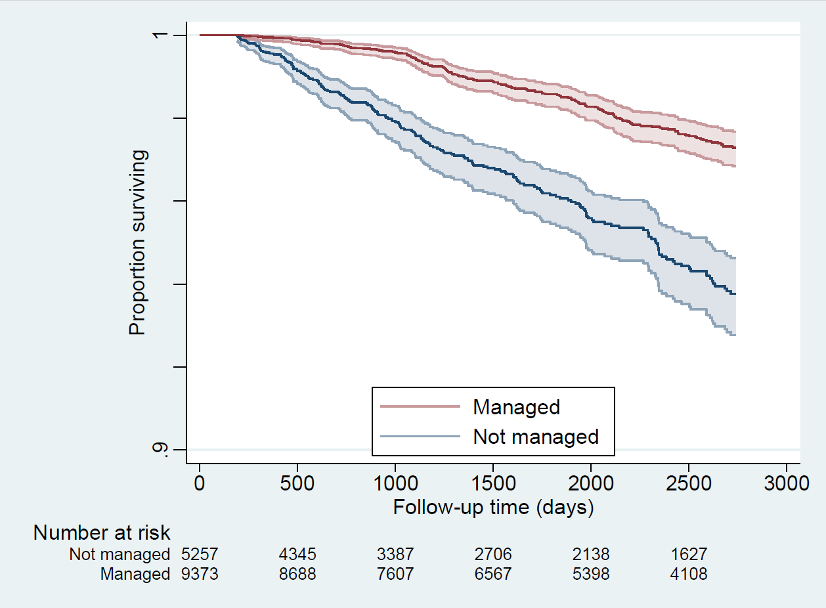

Figure 2. Kaplan-Meier survival curves for all-cause mortality among patients diagnosed with hepatocellular carcinoma who were followed in the Kaiser Permanente Northern California Liver Care Program (red line compared to eligible patients not followed in the program (blue line).

