Rapid case ascertainment using NLP is effective in pancreatic cancer management. This algorithm can be easily and readily applied to other cancers.

Tilak Sundaresan MD, Lisa Herrinton PhD, Liyan Liu MS
Challenge | As part of the broader regional strategy to ensure that our patients receive consultation from experts in their cancer, a sub-specialist group of medical oncologists, surgeons, and others is developing a regional case conference for pancreatic cancer, capturing all diagnoses of resectable pancreatic cancer.  The latest KP Cancer Registry data show that 5 year survival rates for pancreatic cancer in KPNC underperforms relative to SEER data. With this effort, we aim to change this in coming year
Existing Evidence | We have a way to systematically identify all new diagnoses of resectable pancreatic cancer. The list of biopsy confirmed cases (which we will use together with the PAN3 abnormal imaging work) ensures all cases are identified.
Target Population | Pancreatic cancer patients in Kaiser Northern California
Intervention or Exposure | The daily list was sent to a sub-specialist medical oncologist, Dr. Sundaresan, cc-ing Joe Lippi from TPMG consulting services (QOS at the time of this project), who ensured that all appropriate cases are routed to the next available multi-disciplinary case conference staffed by experts in pancreatic cancer.
Outcomes/Key Findings | Oncologists review the weekly new patients during case conference to ensure all appropriate cases are routed to the next available multi-disciplinary case conference staffed by experts in pancreatic cancer
Resulting Action/Change | Totally 783 pancreatic cancer patients were reviewed. Resectable patients were managed properly and promptly. Detailed number of cases by calendar year are as follows  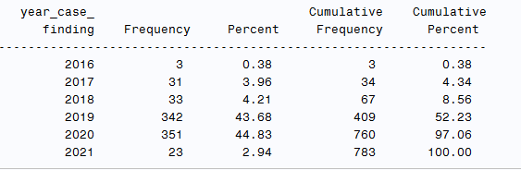
Additional Recommendations | Future evaluations would determine proportions of all diagnosed patients evaluated within the regional conference, impacts on care/outcomes, and heterogeneity of effects (e.g. differences in uptake or outcomes by patient demographics, cancer stage, med center, etc.)
Implementation Tools | Rapid case identification coding and processes for the case conferences
Implementation Measurement | Proportion of patients with pancreatic cancer evaluated within regional case conferences.
Reference

