Structured reporting of lung nodules detected on chest CT was associated with greater chance of detecting early stage lung cancer
Thomas H Urbania, Jennifer R Dusendang, Lisa J Herrinton, Stacey Alexeeff, Douglas A Corley, Sora Ely, Ashish Patel, Todd Osinski, Lori C Sakoda

Challenge | Lung cancer diagnoses require accurate, standardized CT nodule reporting and follow-up methods to optimize timely, appropriate care but none have been validated within KPNC.
Existing Evidence | Although lung cancer is usually diagnosed at a late stage, when diagnosed early, 5-year survival is >50%. Standardized reporting and follow-up may reduce time to diagnosis and provide more accurate diagnoses and more rapid stage-specific care for lung cancer. Methods have been proposed (Fleischner guidelines), but they need integration into KPNC workflows, testing for local accuracy, and potential modification to optimize performance.
Target Population | KP Northern California members undergoing non-screening chest CT imaging.
Intervention or Exposure | Standardized tagging and classification of chest CT pulmonary findings, auto-generated recommendations embedded in CT reports, and coordinated patient follow-up/referral for patients with findings tagged high risk (suggesting lung cancer) by a multidisciplinary care team.
Outcomes/Key Findings | Among 2,856 patients (2.9%) diagnoses with lung cancer, 28% had early-stage disease. 40% percent of all patients received the intervention. The intervention was associated with 9% greater odds of diagnosing any lung cancer (OR 1.09; 95% CI 1.00-1.18); 24% greater odds of early-stage diagnosis (OR 1.24; 95% CI 1.09-1.41); no change in the odds of late-stage diagnosis (OR 1.04; 95% CI 0.95-1.14); and no change in surgical treatment within 120 days.
Resulting Action/Change | These findings supported increased use of standardized tagging, classification, and multi-disciplinary care navigation for identifying early stage lung cancer patients. The intervention did not decrease time to diagnosis; this can inform efforts to decrease time to therapy.
Additional recommendations | Evaluation of steps for time to follow-up and misclassification can further optimize accuracy and expedite next-steps in patient care. Similar imaging tagging/standardized recommendation can be considered more broadly for other conditions.
Implementation Tools | Playbook/workflow for care navigation, reporting system integrated into radiology reports
Implementation and Follow-up Measurements | Proportions of cancers using risk stratification (implementation), early-stage lung cancer diagnosis and time to follow-up following implementation of standardized reporting system (effectiveness); appropriate use of biopsy and surgery (utilization).
Reference(s) [Key Figure if applicable] | Tags, Descriptions, and Recommendations Used to Code Lung-Specific Findings on Diagnostic Chest CT Imaging  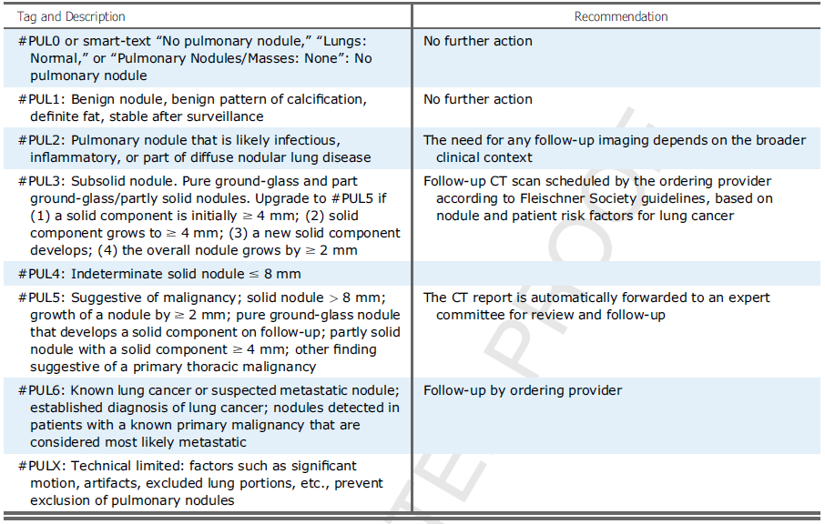  DOI: 10.1016/j.chest.2020.05.595  https://doi.org/10.1016/j.chest.2020.05.595

