Outpatient Mastectomy: Factors Influencing Patient Selection and Predictors of Return to Care
Brooke Vuong, MDª, Jennifer R Dusendang, MPH^{b}, Sharon B Chang, MD, FACS^{c}, Margaret Ann Mentakis, MD, FACSª, Veronica C Shim, MD, FACS^{d}, Julie Schmittdiel, PhD^{b}, Gillian Kuehner, MDe
Challenge | Identifying appropriate patients for surgical home recovery for mastectomy. What factors predict an unplanned return to care?
Existing Evidence | Critics of same day discharge for mastectomy have denounced it as “drive-through” care. Nonetheless, over time and with more robust support services, the physical and psychological benefits of early discharge after breast surgery have been recognized. Rising mastectomy rates across the United States, coupled with the recent COVID-19 pandemic, have driven health care systems to deliver efficient, effective, and safe care to breast cancer patients. Despite multiple retrospective series concluding that outpatient mastectomy is safe, adoption of this practice varies nationwide.
Target Population | Mastectomy cases with and without reconstruction from October 2017 to August 2019
Intervention or Exposure | Same day discharge for mastectomy, including patients undergoing immediate implant-based reconstruction.
Outcomes/Key Findings | Outpatient mastectomies increased substantially during the study interval; complication rates were low (6.6% unplanned return to care). Among 2,648 women receiving mastectomies, 1,689 (64%) were outpatient and the average age of patients was 58.5 years. The average length of stay for inpatient mastectomies was 28.0 hours, compared to 3.2 hours for outpatient mastectomies. Of the 1,689 outpatient mastectomies, only 111 patients (6.6%) had an unplanned return to care (RTC), translating to a 93% success rate for outpatient care. African American ethnicity and American Society of Anesthesiologists Class 3 to 4 increased the odds of having unplanned RTC, whereas bilateral operation or immediate reconstruction was not a significant predictor.
Resulting Action/Change | These results support current practices for surgical home recovery for mastectomy. 92% rate of Surgical Home Recovery for TPMG in Sept 2020 (TPMG Consulting)  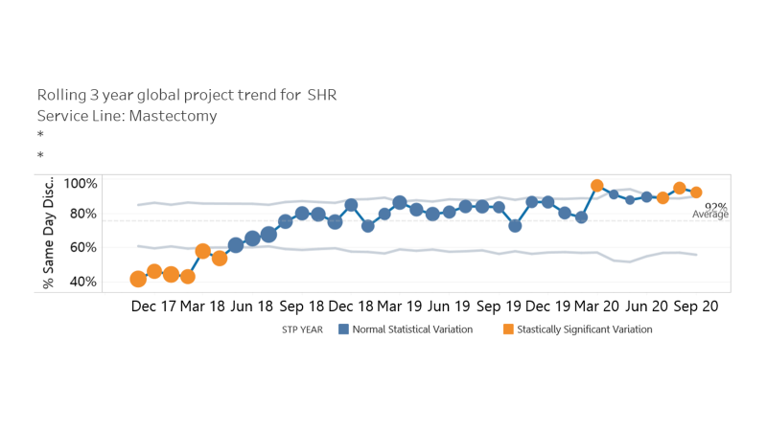  - Oral Presentation at the American College of Surgeons 106th Annual Clinical Congress  - Manuscript in January 2021 Journal of the American College of Surgeons, listed as one of the “Most Read” articles  - Invited Commentary from Dana Farber Cancer Institute  - Division of Research Spotlight Podcast ( Going home after a mastectomy – NCAL Research Spotlight (kaiserpermanente.org))  - “No Place Like Home After Mastectomy” KP Article (https://about.kaiserpermanente.org/our-story/our-care/no-place-like-home-after-mastectomy)  - Meetings to facilitate implementation across the KP Federation (interregional Breast Cancer Group, KP Pacific Northwest, KP Atlanta)  - Surgical Home Recovery highlighted for 2019 Kaiser Permanente National Committee for Quality Assurance Award( https://lookinside.kaiserpermanente.org/region-recognized-for-surgical-care-innovations/)
Additional Recommendations | While several patient, operative, and clinical characteristics may deter surgeons from same day discharge, only ASA Class 3-4 and African-American ethnicity actually increased the risk of unplanned return to care. This specific population may benefit from close post-operative follow-up and additional outreach.
Implementation Tools | Surgical Home Recovery Checklist published in the first article
Implementation Measurement | Unplanned returns to care (readmission, emergency department visit, reoperation) were evaluated for both outpatient mastectomy patients and those admitted overnight.
Reference | 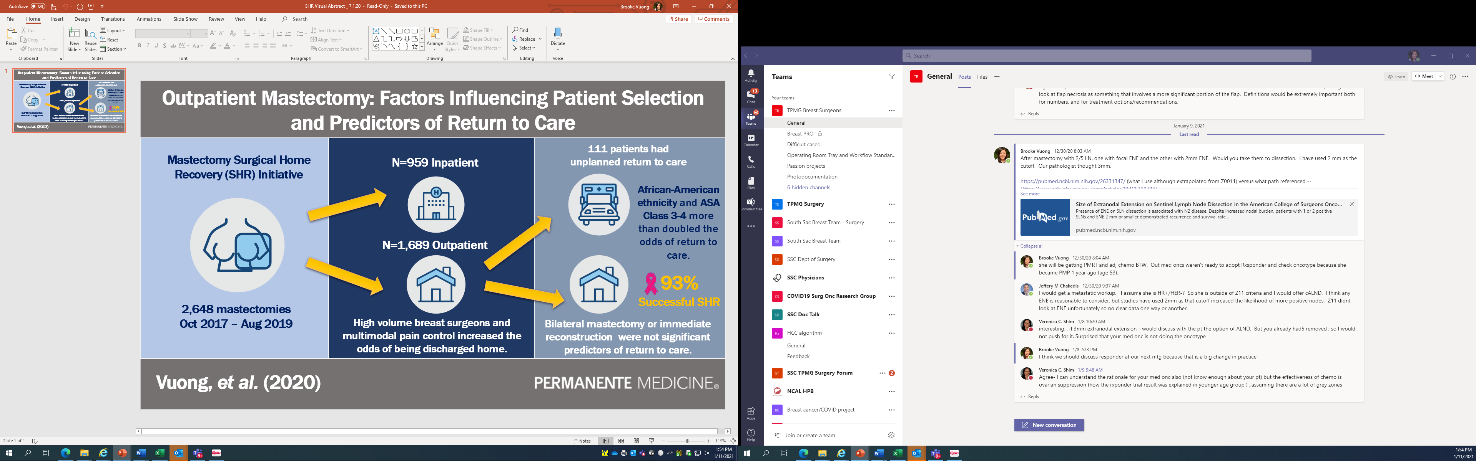  Vuong B, Dusendang JR, Chang SB, Mentakis MA, Shim VC, Schmittdiel J, Kuehner G. Outpatient Mastectomy: Factors Influencing Patient Selection and Predictors of Return to Care. J Am Coll Surg. 2021 Jan;232(1):35-44. doi: 10.1016/j.jamcollsurg.2020.09.015. Epub 2020 Oct 3. PMID: 33022403; PMCID: PMC7532421.  Castillo-Angeles M, Weiss A. Outpatient Mastectomy: No Longer Drive-Through, but Driving into the Mainstream? J Am Coll Surg. 2021 Jan;232(1):44-45. doi: 10.1016/j.jamcollsurg.2020.10.003. PMID: 33308766.  Vuong B, Graff-Baker AN, Yanagisawa M, Chang SB, Mentakis M, Shim V, Knox M, Romero L, Kuehner G. Implementation of a Post-mastectomy Home Recovery Program in a Large, Integrated Health Care Delivery System. Ann Surg Oncol. 2019 Oct;26(10):3178-3184. doi: 10.1245/s10434-019-07551-0. Epub 2019 Aug 8. PMID: 31396779.

