# Evaluation of physical function measure by the PF-5 in Kaiser Permanente Northern California

Michael Yoo, MD; Vincent Liu, MD MSc; Colleen Plimier, MPH; Patricia Kipnis, PhD

|  |  |
| --- | --- |
| **Challenge** | Impairment in physical function (PF) during hospitalization is common, with over a third of hospitalized older adults experiencing a decline from their functional baseline at the time of discharge. Patients with impaired PF, existing prior to admission as well as recognized during hospitalization, are at risk for increased healthcare utilization. While PF is an important aspect of overall health, it is poorly measured and tracked in hospitalized patients. Reliable and standardized PF measurement could improve care processes by recognizing patients who will need physical therapy, home health services, or subacute nursing facilities and stratifying patients at highest risk for adverse post-discharge sequelae. In KPNC hospitals, a novel measure of physical function – the PF-5 PROMIS measure – was implemented in 2021 as the default metric for inpatient function and has been recorded >200,000 times among our inpatients. In this evaluation, our goal was to draw insight from these data to assist our hospital operational partners (leaders over programs including Enhanced Recovery Medicine, Mobility/Physical Therapy, Care Coordination/Discharge Planning) in identifying opportunities to improve physical therapy, utilization, and discharge care processes for KPNC inpatients. |
| **Existing Evidence** | While many tools measuring PF are available, few are developed or implemented in healthcare systems in a standardized fashion to track the functional trajectory of patients during the peri-hospitalization period. Having a real-time, systematic PF tool during hospitalization can help us address current knowledge gaps of whether certain levels of PF are associated with varying types of discharge disposition (e.g., home, home health services, skilled nursing facility) and with other adverse in-hospital and post-discharge outcomes. Our group previously developed the PF-5 tool as a validated and efficient means of assessing inpatient PF, with the collaboration of physicians, nurses, and physical therapists. The current project will specifically use PF-5 to address these knowledge gaps, in particular by 1) evaluating the associations of PF-5 with outcomes such as disposition status, in-hospital falls with or without injury, LOS, readmission, and mortality, 2) assessing the likelihood of discharge disposition and home health services required as a function of PF-5, and 3) gaining insight as to whether the timing, frequency, and intensity of physical therapy are associated with a change in PF trajectory during hospitalization. |
| **Target Population** | We defined our cohort of interest based on the following criteria:   * All hospitalizations with a patient class of Inpatient, Observation, or Admit with Surgery between 3/1/2020 and 7/26/2022 * Adult patients (>=18 years of age at time of admission) * Hospitalizations with length of stay >= 24 Hours * Excluded:   + Maternity- and psych-related hospitalizations   + For post-discharge outcomes (SNF and 30-day mortality), our cohort excludes encounters where patient did not survive to discharge |
| **Intervention or Exposure** | Clinician-assessed level of function scores prior to hospitalization (prior level of function, PLOF) and during hospitalization (current level of function, CLOF) on admission |
| **Methods** | We approached our analyses in the following way:   * Split the data into training (10/1/2021 – 3/31/2022) and validation sets (4/1/2022 – 7/31/2022) * Used logistic regression with binary outcomes (SNF Discharge, PT Consult, Weak mobility, Inpatient death, 30-day mortality) * The models included standard key covariates (Age, BMI, COPS2, LAPS, …), additional clinical predictors, and CLOF/PLOF (see predictors below) * Compared the AUC and AUPRC of models with and without functional status * Built 3 models: * Base model (PLOF, CLOF, and basic covariates) * Base model + Additional Predictors * Base model + CLOF/PLOF ratios * Assessed inter-facility variation in risk adjusted SNF discharge and PT Consult * In a separate analysis we modeled non-custodial (skilled) SNF discharge   + Excluded encounters with custodial SNF 60 days prior to admit |
| **Predictors** | Base model predictors (based on routine EHR data we used in our studies):   * Male * Age * BMI * Admit COPS2.5 * Admit LAPS2.5 * Admit category * First Unit * Care order at Hospital Entry Time (HET)   Additional model predictors (based on clinician/leadership input):   * Insurance Type * Social Work Consult during hospital encounter * Type of Social Support at home * Hospital Census * Prior SNF Type * Hospitalization: Surgical or Medical * Direct hospital admit from SNF   PF5 variables (key covariable of interest):   * First CLOF * First PLOF * CLOF/PLOF Ratio |
| **Outcomes/Key Findings** | We had 3 major findings in our analyses:   1. CLOF and PLOF significantly improved the models’ AUC for all outcomes. The AUC for models with all predictors with CLOF&PLOF vs. predictors without CLOF&PLOF were (Figure 1):    * SNF discharge (including custodial): 0.87 vs 0.78    * Recepti of PT Consult during hospitalization: 0.78 vs 0.70    * Limited achievement of mobility during admission: 0.89 vs. 0.76    * Inpatient death: 0.84 vs 0.82    * 30-day mortality: 0.84 vs 0.83 2. Among models with all predictors including CLOF&PLOF, we found that:    * The number-needed-to-evaluate metric (a measure of clinical workload) for was lowest, when including PF measures, for the non-mortality outcomes for all sensitivity values (Figure 2)    * At high sensitivity (~67%), clinical workup to detection ratio seems sustainable (i.e., evaluate <3 patients to identify 1 who will be discharged to SNF)    * When comparing risk-adjusted outcomes over all KPNC facilities, 5 facilities had lower O/E **SNF discharge** ratios and 5 facilities had O/E higher ratios relative to 1 (Figure 3)    * 9 facilities had lower O/E **PT consult** ratios and 8 facilities had O/E higher ratios relative to 1 (Figure 3) 3. The skilled SNF (rather than including custodial SNF discharges) discharge full model (additional predictors and CLOF&PLOF) exhibited:    * Modestly attenuated performance (lower AUPRC; similar AUC)      + AUC non-custodial vs. including custodial: 0.84 vs. 0.87      + AUPRC non-custodial vs including custodial: 0.3 vs. 0.42    * Higher NNE (clinical workload) for the same sensitivity for the skilled SNF model compared to the model including custodial (Figure 4)    * Inter-facility variation decreased      + 4 facilities had lower O/E ratios and 3 facilities had higher O/E ratios relative to 1 (Figure 5) |
| **Resulting Action/Change** | Our study demonstrated a significant association between CLOF&PLOF and disposition status from the hospital, namely discharge to SNF, that could be predicted on the first day of hospitalization. We also refined and tested our predictive model and determined that it is clinically and operationally sustainable – at high sensitivity, less than 3 patients require evaluation to detect 1 patient who will be discharged to SNF. The goal of our research was to determine if such an association exists and then to discover if a patient’s disposition status is modifiable by measures such as the timing and dose of physical therapy consultation. We have presented our preliminary results at several regional meetings to SNF and Mobility leadership and have mapped out the course and trajectory of a patient’s journey from pre-hospitalization disposition to discharge to understand how our model can be utilized clinically within KPNC. There is great interest in using our findings to assist with inpatient discharge disposition as well as interest in understanding how physical therapy consultation can improve outcomes related to hospital admission. |
| **Additional Recommendations** | N/A |
| **Implementation Tools** | We plan to develop tools and workflows using the PF-5 to target these interventions that will be built into the EHR. Since the PF-5 is already available in the EHR today and is a standard part of nursing documentation, additional teams (inpatient operations/quality, physical therapy) are identifying potential |
| **Implementation and Follow-up Measures** | With regional leadership support, we plan to further develop workflows to impact hospitalized patients and track metrics and outcomes of healthcare utilization using the patient mobility dashboard that has already been built and is currently active – these include frequency of PF-5 T-score, PT consults, max mobility score, patient disposition and falls with and without injury. The patient mobility dashboard was initially rolled out at pilot test sites but now has reach across all KPNC hospitals. Effectiveness of the program can be measured by tracking metrics regularly (monthly, quarterly, annually) and by conducting subsequent analyses. |
| **Reference(s)** | Callahan KE, Lovato L, Miller ME, et al. Self‐reported physical function as a predictor of hospitalization in the lifestyle interventions and independence for elders study. J Am Geriatr Soc. 2018;66(10):1927-1933.  Covinsky KE, Palmer RM, Fortinsky RH, et al. Loss of independence in activities of daily living in older adults hospitalized with medical illnesses: increased vulnerability with age. Journal of the American Geriatrics Society. 2003;51(4):451-458.  Greysen SR, Stijacic Cenzer I, Auerbach AD, Covinsky KE. Functional impairment and hospital readmission in medicare seniors. JAMA Intern Med. 2015;175(4):559.  Kallen MA, Brown HE, Hatton JR, et al. New complementary perspectives for inpatient physical function assessment: matched clinician-report and patient-report short form measures from the PROMIS adult physical function item bank. Qual Life Res. 2022;31(7):2201-2212.  See Table and Figures below |

Targeted Analysis Program: Supplemental Questions

Please answer the below questions in narrative form:

1. Please provide a detailed plan for dissemination of the project results to stakeholders, especially clinical and operational leadership? (Be as specific as possible; up to ½ page)

We have already presented our study findings to clinical and operational leadership at the SNF Strategy Leaders Meeting on April 20th, 2023, and at the Monthly Mobility Directors & Regional Team Meeting on October 18th, 2023. We have gained insights from these meetings on implementation strategies for our PF5 model regionally, with plans to conduct further analyses and follow-up again with our stakeholders as the implementation process moves forward. We are planning to draft and submit a manuscript of our findings to date by the end of 2023 / early 2024.

1. Please provide a draft of manuscript (if applicable). If no manuscript is planned or in process, please attach tables and figures that outline the results here.

**Table 1. Patient Characteristics**

| **Characteristic** | **Missing** | **No SNF**, N = 104,074*1* | **SNF**, N = 14,174 (12.0%)*1* |
| --- | --- | --- | --- |
| **First CLOF score (Current)** | 0 (0%) | 35.0 (26.0, 45.0) | 19.0 (14.0, 25.0) |
| **PLOF score (Prior)** | 16,125 (14%) | 44.0 (33.0, 54.0) | 29.0 (22.0, 38.0) |
| **CLOF at discharge** | 16,390 (14%) | 39.0 (32.0, 55.0) | 20.0 (15.0, 26.0) |
| **CLOF/PLOF Ratio** | 16,125 (14%) | 0.9 (0.7, 1.0) | 0.7 (0.5, 0.9) |
| **MALE** | 725 (0.6%) |  |  |
| 0 |  | 50,538 (48.9%) | 7,737 (54.7%) |
| 1 |  | 52,837 (51.1%) | 6,411 (45.3%) |
| **Age at admit** | 0 (0%) | 68.0 (55.0, 79.0) | 78.0 (70.0, 86.0) |
| **BMI** | 1,794 (1.5%) | 27.4 (23.4, 32.5) | 26.5 (22.5, 32.1) |
| **COPS2.5 at admit** | 99 (<0.1%) | 29.0 (10.0, 65.0) | 47.0 (20.0, 84.0) |
| **LAPS2 at admit** | 180 (0.2%) | 63.0 (37.0, 91.0) | 80.0 (51.0, 108.0) |
| **Admit category** | 0 (0%) |  |  |
| Unscheduled, less than 24 hours prior to admission |  | 88,690 (85.2%) | 13,371 (94.3%) |
| Scheduled, at least 24 hours prior to admission |  | 15,284 (14.7%) | 789 (5.6%) |
| Unknown |  | 100 (0.1%) | 14 (0.1%) |
| **Unit 1** | 0 (0%) |  |  |
| FLR |  | 74,102 (71.2%) | 10,836 (76.4%) |
| ICU |  | 8,285 (8.0%) | 1,521 (10.7%) |
| OR |  | 18,328 (17.6%) | 1,410 (9.9%) |
| TCU |  | 490 (0.5%) | 43 (0.3%) |
| UNKNOWN |  | 2,869 (2.8%) | 364 (2.6%) |
| Hospital daily census | 3 (<0.1%) | 125.0 (92.0, 179.0) | 131.0 (93.0, 180.0) |
| Hospital daily census/median census ratio | 3 (<0.1%) | 1.0 (0.9, 1.1) | 1.0 (0.9, 1.0) |
| SNF prior 60 days | 0 (0%) | 2,656 (2.6%) | 3,365 (23.7%) |
| SNF type prior 60 days | 0 (0%) |  |  |
| No SNF |  | 101,418 (97.4%) | 10,809 (76.3%) |
| Custodial |  | 268 (0.3%) | 1,136 (8.0%) |
| Skilled |  | 2,388 (2.3%) | 2,229 (15.7%) |
| Admit direct from SNF | 0 (0%) |  |  |
| Yes |  | 782 (0.8%) | 2,417 (17.1%) |
| Hospital admit category | 0 (0%) |  |  |
| MEDICAL |  | 60,604 (58.2%) | 8,071 (56.9%) |
| SURGICAL |  | 43,470 (41.8%) | 6,103 (43.1%) |
| Insurance | 0 (0%) |  |  |
| Commercial HMO |  | 35,801 (34.4%) | 1,877 (13.2%) |
| Medi-Cal |  | 5,154 (5.0%) | 293 (2.1%) |
| Medi-Medi (Mcare Risk) |  | 5,800 (5.6%) | 1,334 (9.4%) |
| Medicare Risk |  | 47,769 (45.9%) | 9,426 (66.5%) |
| Misc/Unknown |  | 9,550 (9.2%) | 1,244 (8.8%) |
| Social support at home info collected | 0 (0%) | 618 (0.6%) | 121 (0.9%) |
| Social support at home | 0 (0%) |  |  |
| Live alone in own home |  | 142 (0.1%) | 38 (0.3%) |
| Live in a household with other people |  | 420 (0.4%) | 65 (0.5%) |
| Nursing home or residential facility |  | 39 (0.0%) | 14 (0.1%) |
| Unknown/Other |  | 103,463 (99.4%) | 14,056 (99.2%) |
| Housing insecurity |  | 10 (0.0%) | 1 (0.0%) |

**Figure 1. Model Discrimination**

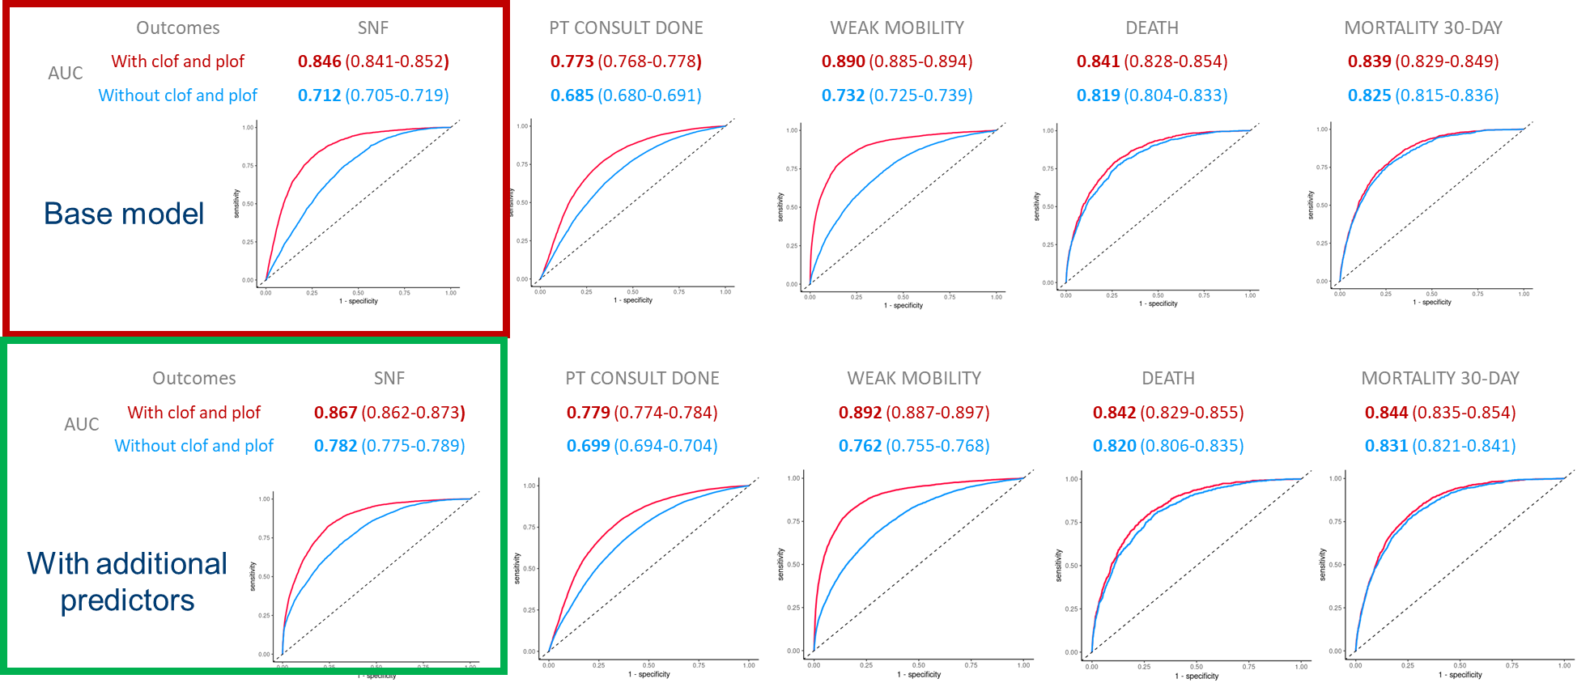

**Figure 2. Models’ Number Needed to Evaluate (NNE) vs. Sensitivity**

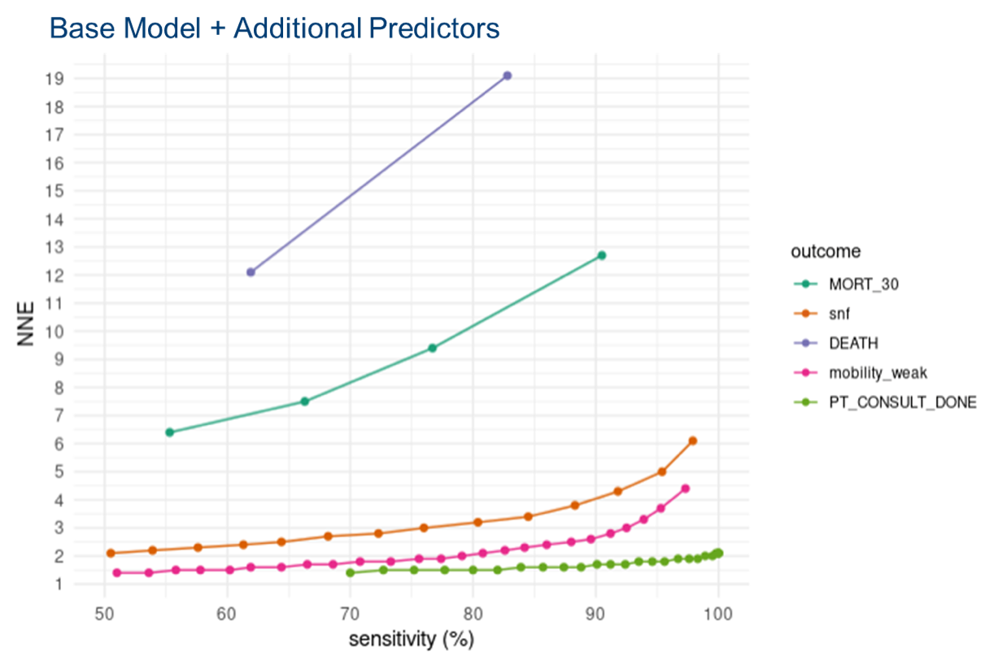

**Figure 3. Inter-facility Observed to Expected Ratios**

**SNF Discharge PT Consult**

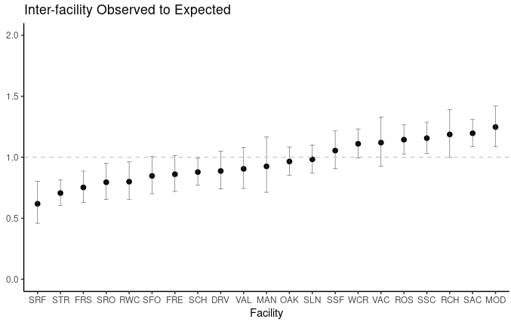 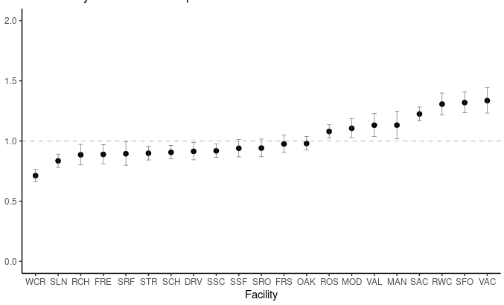

**Figure 4. Skilled SNF Model Number Needed to Evaluate (NNE) vs. Sensitivity**

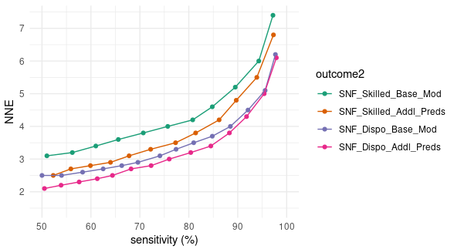

**Figure 5. Inter-facility Observed to Expected Ratios for Skilled SNF Discharge Model**

**Skilled SNF Discharge SNF Discharge**

 