Perinatal nutritional management associated with improved pregnancy outcomes among women post-bariatric surgery
Mara Greenberg, MD, Monique Hedderson, PhD

Challenge | Patients frequently have pregnancies post-bariatric surgery within KPNC, but the effectiveness of existing nutritional management efforts to improve pregnancy outcomes is unknown.
Existing Evidence | Prior studies women post-bariatric surgery had small numbers inconclusive results regarding impact adverse pregnancy outcomes. Approximately 73% of post-bariatric surgery pregnancies are referred to the Regional Perinatal Service Center (RPSC), which requires multiple laboratory evaluations and adjustment of nutritional supplements. It is unknown whether this service improves pregnancy outcomes.
Target Population | KPNC enrolled women with pregnancy post-bariatric surgery.
Intervention or Exposure | Enrollment in Regional Perinatal Service Center for nutritional management.
Outcomes/Key Findings | Among women post-bariatric surgery, pregnancies enrolled in the Regional Center were less likely to have a preterm birth, experience hypertensive disorders (including pre-existing HTN, gestational HTN and preeclampsia), or to be admitted to the NICU. There were no differences for cesarean deliveries and gestational or pre-existing diabetes. Among all women post-bariatric surgery, >20% had HTN, >40% had impaired glucose tolerance or diabetes, and many (39%) were delivered by cesarean.
Resulting Action/Change | The results support the effective use of the Regional Perinatal Service Center for nutritional management and monitoring of post-bariatric surgery patients. These findings support improving rates of referral and uptake and efforts to identify which program components are most associated with better outcomes.
Additional recommendations | Consideration of additional measures for identifying and referring appropriate patients for nutritional evaluation
Implementation Tools | None; tools could be developed around increasing awareness and referral
Implementation and Follow-up Measures | RPSC referrals among women post-bariatric surgery (implementation); ongoing perinatal outcomes following referral (effectiveness); complications (utilization).
Reference(s) [Key Figure if applicable] | 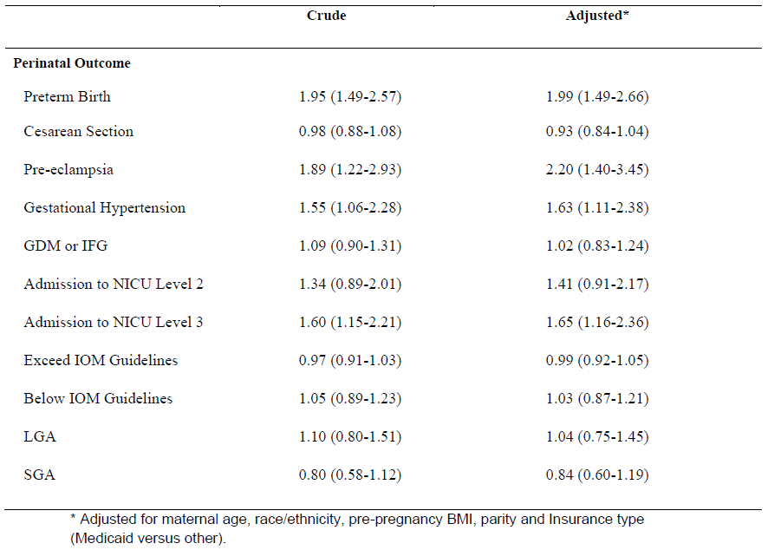  Risk for perinatal outcomes among women not referred to RPSC (internal report).

