TARGETED SURVEILLANCE BOOSTS SKIN CANCER SCREENING AND DETECTION IN
HIGH-RISK SOLID ORGAN TRANSPLANT RECIPIENTS
David S. Lee, MD, Lusine Gigoyan, MPH, Ryan E. Sells, MD, Joshua R. Nugent, PhD, Nelson B. Goes, MD,
Hugh R. Harris, MD, Erna O. Nishime, MD, Gurpreet K. Rihal, MD, David L. Conant, MD, Ngoc Pham, MD, Marilyn L. Kwan, PhD
Challenge | Solid organ transplant recipients (SOTRs) face a significantly increased risk of skin cancer due to chronic immunosuppression. Effective surveillance is critical to reduce morbidity and mortality, yet adherence to regular screening is low.
Existing Evidence | The elevated risk of skin cancer in SOTRs is well established. Skin cancers in SOTRs are more aggressive, with nearly nine-fold higher cancer-specific mortality than the general population.  The Skin and Ultraviolet Neoplasia Transplant Risk Assessment Calculator (SUNTRAC) was published in 2019, stratifying SOTRs into Low, Medium, High, and Very High risk tiers based on the following established patient risk factors: race, pre-transplant skin cancer history, age at transplant, sex, and transplanted organ.
Target Population | Patients aged 18 years or older who underwent solid organ transplantation between January 1, 2016, and December 31, 2023
Intervention or Exposure | The KP-SUNTRAC program, a modified version of SUNTRAC, was implemented to optimize skin cancer surveillance, targeting High and Very High risk SOTRs for annual screenings in Dermatology starting January 2022, and Low and Medium risk SOTRs for annual screenings in Adult and Family Medicine starting January 2024.
Outcomes/Key Findings | Post-implementation, screening rates improved significantly in High (HR=1.98, 95% CI:1.39-2.82) and Very High (HR=2.17, 95% CI:1.21-3.86) risk groups, and the risk of first detected skin cancer increased significantly (HR=2.57, 95% CI: 1.76-3.73). No increase in healthcare resource utilization was observed.  The nested case-cohort study revealed that SOTRs had a 7.8-fold increased risk of developing skin cancer compared to non-SOTRs at KPNC, with increased risks for cSCC (HR=10.90, 95% CI: 7.24-16.40) and BCC (HR=5.56, 95% CI: 3.87-7.98).
Resulting Action/Change | The KP-SUNTRAC program demonstrated that targeted surveillance improves skin cancer screening and detection rates without additional resource burden, supporting its broader implementation.
Additional Recommendations | Enhance awareness of the KP-SUNTRAC program in Adult and Family Medicine. Increased engagement and education about the program will ensure timely and comprehensive screenings for all SOTRs, including those at Low and Medium risk.
Implementation Tools | Manuscript submission to JAMA (impact factor 63.5) or JAMA Dermatology (impact factor 10.9). Submit results for presentation at dermatology and transplant conferences. Disseminate findings and recommendations to organizational leadership and stakeholders.
Implementation Measurement | Quarterly screening rates, skin cancer detection rates, and resource utilization metrics, categorized by service area, medical center, and organ type.
Reference | Please see below from the submitted manuscript highlighting key study findings

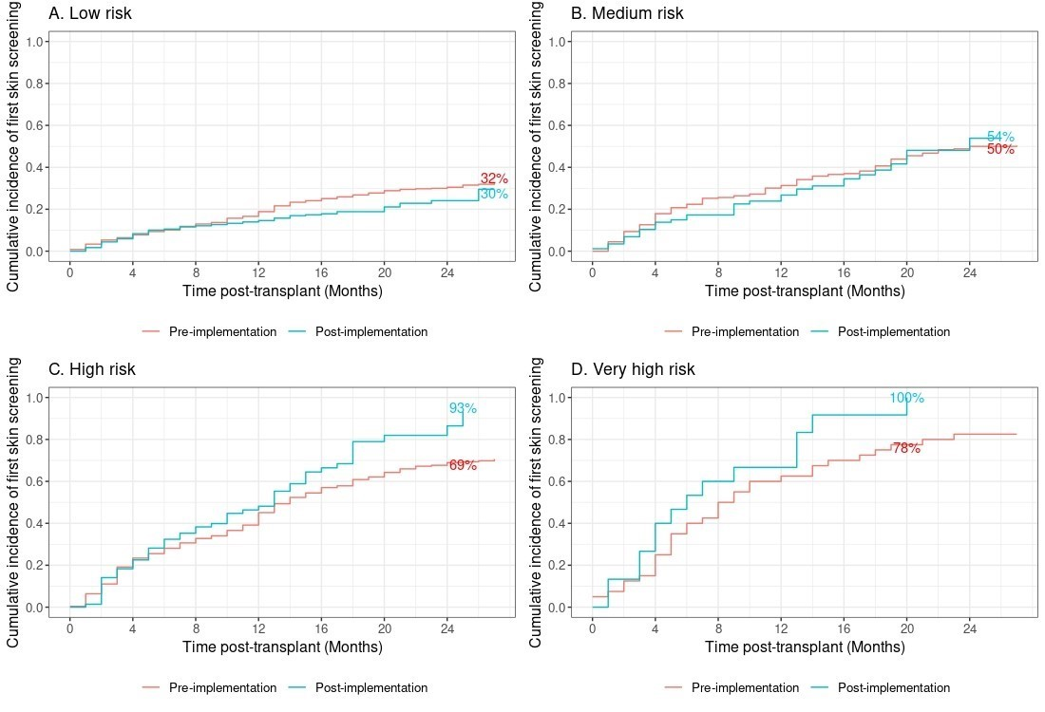
Figure 1. Time to first skin cancer screening stratified by original SUNTRAC risk group. No individuals are at risk in the Medium risk group in the post-implementation cohort beyond week 26 (B), no individuals are at risk in the High risk group beyond week 25 (C), and no individuals are at risk in the Very High risk group beyond week 20 (D).

Supplemental Table 7. Adjusted association between time to first skin cancer screening by original SUNTRAC risk group
 | HR¹ | 95% CI¹ | P value
Low risk  Post vs. Pre | 1.15 | 0.81, 1.62 | 0.42
Medium risk  Post vs. Pre | 1.39 | 0.99, 1.95 | 0.05
High risk  Post vs. Pre | 1.98 | 1.39, 2.82 | <0.001
Very High risk  Post vs. Pre | 2.17 | 1.21, 3.86 | <0.001
¹ Hazard Ratio (HR) and Confidence Interval (CI) estimated from Cox proportional hazards model adjusted for intervention group, original SUNTRAC risk level, year of transplant, and interaction term (intervention group x SUNTRAC risk level)
² Sensitivity analysis excludes COVID-19 period from March 1, 2020, to December 31, 2021
Table 2. Associations between patient characteristics and risk of first detected skin cancer after solid organ transplant
 | Pre-Implementation¹ No. | Post-Implementation¹ No. | HR^{2,3} | 95% CI^{2,3} | P value
KP-SUNTRAC intervention group
Pre-implementation | 1,502 | — | — | —
Post-implementation | — | 581 | 2.57 | 1.76, 3.73 | <0.001
¹ Pre-implementation period: January 31, 2016-December 31, 2021, Post-implementation period: January 31, 2022-March 31, 2024
² Hazard Ratio (HR) and Confidence Interval (CI) estimated from Cox proportional hazards model adjusted for clustering effect of service area, year of transplant, and other covariates in the table
³ Follow-up was for 27 months starting date of transplant in the SOTRs to the earliest of the following dates: first skin cancer diagnosis (study outcome), HIV diagnosis, subsequent organ transplantation, disenrollment from the health plan (allowing any gaps as long as patient re-enrolled during study period), death, and end of the study (March 31, 2024 for post-implementation group and Dec. 31, 2021 for the pre-implementation group).

Supplemental Table 8. Healthcare utilization counts before and after KP-SUNTRAC implementation in High and Very High risk patients during 27 months from date of transplant
Characteristic | Pre-Implementation (January 2016-December 2021)  N=275 |  |  | Post-implementation (January 2022-March 2024)  N=88
 | Dermatology Appointment Counts | Non-Dermatology Appointment Counts | Pathology Specimen Counts | Dermatology Appointment Counts | Non-Dermatology Appointment Counts | Pathology Specimen Counts
 | mean / median (min-max) |  |  | mean / median (min-max)
Overall | 2.1/1.0 (3-34) | 3.7/0 (0-38.0) | 1.9/1.0 (1.0-6.0) | 1.8/1.0 (0-9) | 2.0/0 (0-19.0) | 1.8/1.0 (1.0-5.0)

Supplemental Table 4. Incidence rates and hazard ratios of risk of all skin cancers in solid organ transplant recipients (SOTR) compared with individuals with no history of SOTR (non-SOTR) at KPNC, January 2022-March 2024
 | Skin Cancer Incidence  per 100 person-years (95% CI) |  | HR (95% CI)²
 | SOTR  (n=2,083) | Non-SOTR¹ (n=26,199)
SOTR vs Non-SOTR | 2.36 (2.04, 2.73) | 0.12 (0.10, 0.15) | 7.78 (5.97, 10.1)
¹ Matched on sex, race/ethnicity, and facility
² Hazard Ratio (HR) and Confidence Interval (CI) estimated from Cox proportional hazards model adjusted for other covariates in the table

