SGLT2 Inhibitors are associated with an increased risk of ketoacidosis, but the overall risk is so low that proceeding with surgery may be more appropriate than delaying care.
Brendan Seto, MD, Michael Hartman, MS, Julie Schmittdiel, PhD, Bradley Cohn, MD
Challenge | SGLT2i medications are widely prescribed for the management of diabetes, kidney disease and heart failure. The FDA cautions clinicians that exposure to these medications prior to surgery can increase the risk of ketoacidosis. Withholding these agents for 3+ days prior to surgery is logistically complex and not always possible. If not withheld, patients and their care teams are often faced with the difficult decision of accepting higher risk surgery or delaying care.
Existing Evidence | The incidence of perioperative ketoacidosis is not well defined, hence the relative importance of exposure to SGLT2i is unknown.
Target Population | Adult patients scheduled for surgery or medical procedural interventions.
Intervention or Exposure | 1. SGLT2i prescriptions filled prior to surgery  2. Continuation of these medications prior to surgery
Outcomes/Key Findings | The baseline risk of postoperative ketoacidosis after scheduled surgery is low (0.09%). Patients with ketoacidosis are more likely to have an active SGLT2i prescription (adjusted OR 2.50, 95% CI: 1.98-3.16). Patients with ketoacidosis are more likely to have continued SGLT2i preoperatively (OR 3.06, 95% CI: 1.69-5.57). There was a 65% greater day-of-surgery cancellation rate among SGLT2i users.
Resulting Action/Change | This evidence supports the recommendation to withhold SGLT2i preoperatively, however, given the rarity of this event, the absolute risk of ketoacidosis may be less than the risk of deferring surgery when this guidance is not followed.
Additional Recommendations | These data should allow clinicians personalize risk assessments among patients exposed to SGLT2i prior to surgery.
Implementation Tools | Data on overall rate of postoperative ketoacidosis by case service (surgical specialty) are expected to influence the TPMG Perioperative Diabetes Mellitus and Glucose Management and Perioperative Medication Management Guidelines .
Implementation Measurement | We anticipate updated clinical guidance for the management of patients prescribed SGLT2i to have a measurable impact on day-of-surgery cancellation rates in this cohort.  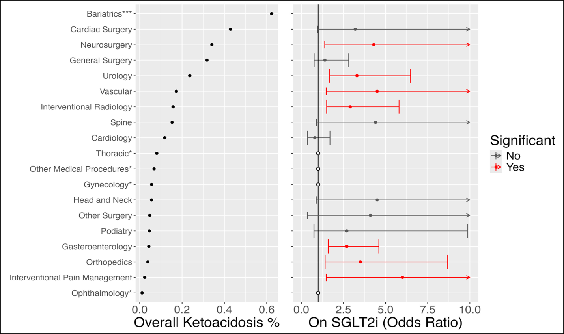
Reference

