Delivery Science Grants Program
Implementation of Tenecteplase Beyond 4.5-hour in a Large Community-based Cohort Study)
Principal Investigator: Mai N. Nguyen-Huynh, MD MAS Co-investigators: Jeffrey Klingman MD; David Vinson MD; Anne C Kim MD; Molly Burnett MD; Sheila Chan MD;Patricia Zrelak PhD RN; Catherine Lee PhD; Joeffrey R. Hatton, MBA; Hemali Sudhalkar, MD
Project start and end dates: 7/1/23 – 6/30/25
Challenge | In a real-world practice setting, what are the effects on stroke care processes and clinical outcomes when IV tenecteplase (TNKase) is used to treat patients with potential acute ischemic stroke presenting with wake-up stroke or within 4.5 to 9 hours from last known well?
Existing Evidence | The NINDS IV-TPA trial² first showed that IV alteplase was beneficial in select patients with AIS if given within 3 hours after symptom onset. Later trial data extended the window to 4.5 hours. Alteplase is the only FDA-approved IV thrombolytic treatment for AIS. Since 2018, DEFUSE-3 and DAWN trials used advanced neuroimaging screening to identify qualifying patients with LVO in the extended window (6-24 hours) for endovascular therapy. But the vast majority of acute stroke patients have no LVO and therefore no acute treatment options if presenting >4.5 hours. WAKE-UP trial used MRI brain findings to randomize patients with wake-up stroke to IV alteplase or placebo. The treatment group achieved better functional outcome at 90 days. There was a higher rate of sICH with alteplase, but it did not negate the benefit of treatment. A meta-analysis of 3 trials that screened patients presenting in 4.5-9 hours with MR/CT perfusion showed better functional outcome in those treated with IV alteplase. The 2019 AHA acute ischemic stroke guidelines included a new recommendation (Class IIa, B) that in patients who awake with stroke symptoms or have unclear time of onset >4.5 hours, MRI to identify mismatch criteria can be useful in selecting those who may benefit from IV alteplase within 4.5 hours of stroke symptom recognition. The 2021 European Stroke Organization guidelines recommend that patients presenting as wake-up stroke or in the 4.5- to 9-hour window from LKW time who meet advanced neuroimaging criteria with either MRI or CT perfusion be considered for IV alteplase. TNKase for AIS has been evaluated in several clinical trials to date (within 4.5 hours from LKW and in those with LVO in the extended window) and has generally been determined non-inferior to the FDA-approved stroke thrombolytic alteplase. However, to date, there has been only one report of its use in a community setting, and no reports of TNKase usage in patients presenting as wake-up stroke or in the 4.5- to 9-hour window from LKW.
Target Population | Acute ischemic stroke patients presenting as wake-up stroke or within 4.5 to 9 hours from last known well.
Intervention or Exposure | Treated with tenecteplase (TNKase) using new workflow
Outcomes/Key Findings | Outcomes:  - Aim 1: Primary outcomes: Proportion of eligible patients who were screened with CTP and/or MRI brain; proportion of screened patients who meet clinical criteria for IV TNKase. This is a purely descriptive aim in order to allow us to finalize and implement the new screening workflow as shown in the diagram.  - Aim 2: Primary outcomes: sICH rate as defined by SITS-MOST criteria.  - Aim 3: Primary outcome: 90-day mortality.  - Secondary outcomes: inpatient mortality, length of stay, discharge disposition, 90-day favorable functional outcome (mRS 0-2).  Key Findings: During the 21-month study period, 13,634 stroke alerts occurred in the extended window; of which 726 met clinical criteria and underwent further workup. The final study cohort included 449 patients without hemorrhage on head CT and not requiring EVT. Of these, 24 (5.3%) were treated with TNKase [Figure]. Among those treated, 14 (58.3%) were wake-up strokes. TNKase-treated patients were more likely to be walk-ins (25% vs. 11.6%; p = 0.05) and had longer times from LSN to ED arrival (8.7 hours vs. 6 hours; p < 0.001) [Table 1]. Inpatient mortality (0% vs. 8%; p = —) and 90-day mortality (4.2% vs. 16.2%; p = 0.11) were suggestively lower in the TNKase group [Table 2]. One treated patient (4.3%) experienced symptomatic intracranial hemorrhage (sICH). For 90-day mRS among those treated, 8 were missing, and 25% (95% CI: 7.3–52.4) achieved mRS 0–2. Over 21 months, relatively few patients presenting as wake-up stroke or in the 4.5–9 h window met all clinical and advanced neuroimaging criteria for TNKase in a large, integrated healthcare system. Rates of sICH and 90-day mortality were low. Additional studies are needed to understand the cost-effectiveness of screening and treating this population in the extended window.  In Table 3, our community cohort’s outcomes for treatment time, 90-day mortality and sICH rate were comparable to those published from clinical trials. However, for the 90-day mRS (or functional outcome), due to 8 missing data (out of 24 who were treated), we cannot make any conclusions at this time about this outcome.
Resulting Action/Change | Data was presented to telestroke group on 8/19/25. Planned presentation to next quarterly stroke directors meeting on 11/10/25.  We do not see any increased complication with sICH post-TNKase treatment in the extended window as long as teleneurologists follow the outlined workflow. It may be reasonable for the Telestroke neurologists to continue to screen wake-up stroke patients and patients presenting in 4.5-9 hours with the outlined workflow.
Additional Recommendations | We should review this workflow again after we try to capture the 90-day mRS for the missing 8 patients.
Implementation Tools | 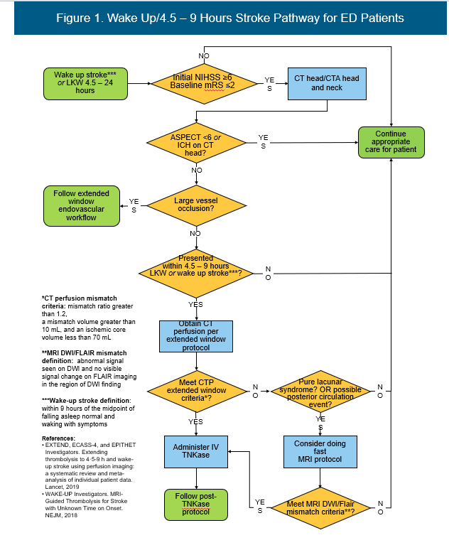
Implementation Measurement | 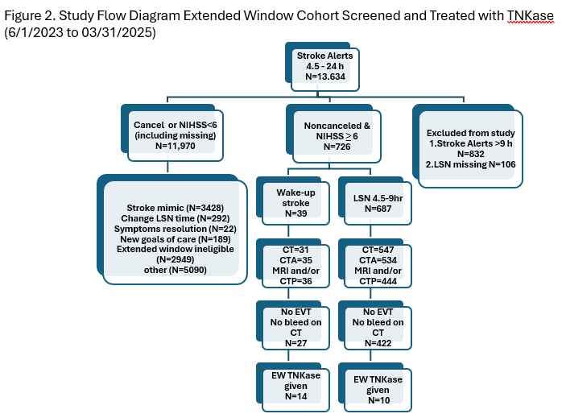
Reference | 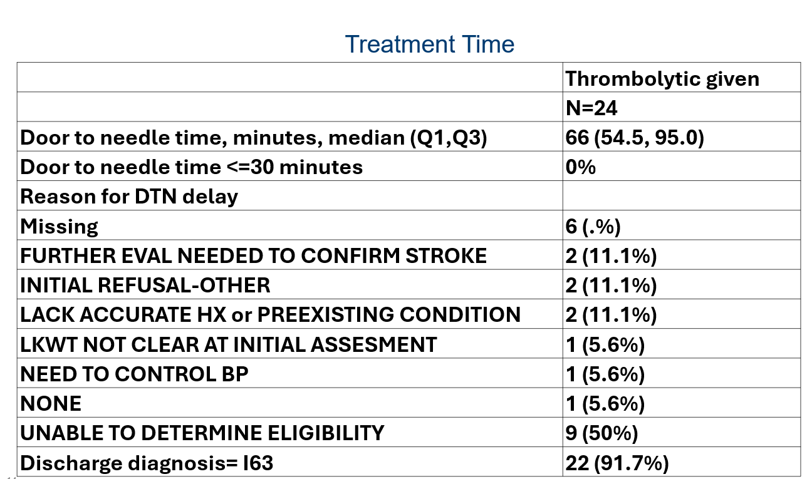  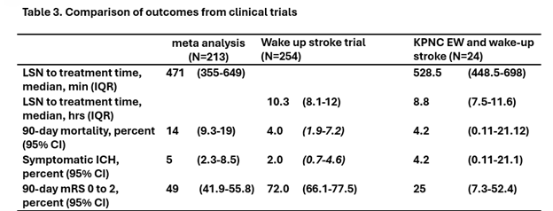
In carrying out this project, what problems or barriers did you encounter? (50 words or less) | The wake-up stroke population is difficult to identify since the revised telestroke note did not include a separate question on whether someone presented with a wake-up stroke or not. We had to identify this population by finding the term “wake up stroke” in the note and also by identifying people with last time know well before the day of their presentation to the ED. There was also difficulty with complete data extraction with CT perfusion. The number of CT perfusion was initially really low and not what we expected. We worked with NeuroRad to capture CT perfusion more fully. There was incomplete capture of 90-day modified Rankin scale (mRS) score (by the local stroke teams) for patients who were treated with tenecteplase. We will need to do chart review again to see if we can categorize these patients’ functional status after treatment. Or, we may need to contact the patients ourselves.
In your experience with this project, what was the most positive or constructive aspect? (50 words or less) | Working with telestroke group and giving them feedback.
Dissemination -- did your project lead to a presentation, report or publication? | ☐ No, please describe barriers, if any.  ☒ Yes, please list. Submitted ISC abstract and presented to telestroke group in Aug 2025. We are planning manuscript for submission towards end of this year.
Did you or others learn something else from your project? | ☐ Formed a new relationship  ☒ Learned that the right data aren’t currently available  ☒ Identified unanticipated barriers to improving clinical practice  ☐ Other learnings:  *** Unable to change telestroke notes to capture wake-up stroke patients accurately.

