Delivery Science Grants Program
Predicting and Preventing Suicide at Entry to Mental Health Care: A Community-Engaged, Machine Learning Model Implementation

Honor Hsin, MD PhD;¹ Santiago Papini, PhD;² Yun Lu MD, MPH;³ Heather Clancy, MPH;³ Megan Erion, PsyD;¹ Carrie Lee, LCSW, MPH;¹ Kimberly Brochard-Des Roches, LMFT;¹ Jinghui Ju, PhD;¹ Kristine Girard, MD;¹ Maria Koshy, MD;¹ Sameer Awsare, MD;¹ Stacy A. Sterling DrPH, MSW, MPH;³ Vincent X. Liu MD, MS;³ Esti Iturralde, PhD³

Challenge | The US suicide rate remains on the rise, with 49,476 lives lost to suicide in 2022.¹ Interventions at the system level and directly with patients can reduce suicidal behaviors when focused on individuals at elevated risk.^{2,3,4} How to screen effectively for suicide risk is not well understood, however, nor are the potential burdens of this screening.³ Machine learning (ML) models have been developed recently from electronic health records (EHR) to predict suicide risk.^{5,6,7,8} Using variables such as past clinical diagnoses, medication history, mental health care utilization, and medical history, these models have demonstrated high accuracy at identifying patients at risk for a suicide attempt within 90 days.⁵ Research has begun to examine the impact of harnessing this prediction approach in care delivery; yet no clear implementation pathways exist given the knowledge gap in burdens of suicide risk screening.^{9,10,11,12,13} There is also concern among implementers that ML models could perpetuate societal inequities if they are trained on data that may be incomplete for populations facing barriers to care.  Kaiser Permanente Northern California (KPNC) serves a diverse population of approximately 4.6 million members, with a prevalence of mental health conditions comparable to US rates.¹⁴ KPNC has been a pioneer in telemedicine including in telepsychiatry, with video visit availability preceding the COVID-19 pandemic. As far back as 2018, the system provided initial mental health assessments (“intake” appointments) by specialized clinicians working virtually. Leaders recognized value in implementing suicide risk prediction for these virtual intake visits. A mental health intake with a clinician is the first step to establishing an episode of care, which may include therapy, medication management, addiction treatment, and/or intensive care options. In 2020, KP had also implemented a systematic system for measurement-based care. This platform includes a widely-used, brief questionnaire completed by the patient to describe their depression symptoms, the Patient Health Questionnaire-9 or PHQ-9, which includes an item on suicidal thoughts. If significant suicidal ideation is reported, an EHR alert reminds clinicians to complete a suicide risk assessment with the patient during the visit.  Clinical operation leaders determined this would be a high-value opportunity to pilot enhanced suicide prevention efforts. Indeed, the intake visit is a unique point-of-care in a patient’s mental health journey, as over 70% of treatment disengagement occurs after the first or second visit.¹⁵ Identifying at-risk individuals at intake can help ensure that appropriate suicide risk evaluation and treatment planning take place as patients are connecting to care.
Existing Evidence | In 2018, investigators from a consortium of health system–embedded researchers, the Mental Health Research Network, published an EHR machine learning algorithm for predicting risk of suicide attempt within 90 days of a mental health visit.⁵ In this model, both intake and mental health return visits were considered index events. Harnessing a prediction approach in care delivery, however, remains an underdeveloped area even as research has begun to examine the impact of these models on clinical workflows.^{9,10} While some argue that the substantial rate of false positives limits utility of these models,¹¹ others note that the level of accuracy at risk identification is comparable to other areas of preventive medicine.¹² Furthermore, a net-benefit calculation that considers the relative value of intervening in true-positive cases, compared with not intervening in false-positive cases, may provide a useful guide for clinical action across various decisional thresholds.¹³
Target Population | Aim 1: KPNC members scheduled for a mental health intake visit between 1/1/12 to 4/1/22, aged ≥ 18 years at time of intake visit.  Aim 2:  - KPNC members aged ≥ 18 years who completed a virtual mental health intake visit between 1/1/22 and 7/1/22, who endorsed suicidal ideation during virtual mental health intake with PHQ-9 question #9 > 0.  - KP clinician managers practicing at KP SSF, KP SJO, and C2C sites.  Aim 3: KP clinician managers practicing at KP C2C site.
Intervention or Exposure | Aim 1: none  Aim 2: none  Aim 3: none
Outcomes/Key Findings | We adapted ML modeling to our population’s needs with a five-step implementation approach (see figure):  - Assess whether the predictive model accurately estimates suicide risk for patients seeking new mental healthcare, including for patients in various demographic subgroups;  - Speak to patients with past experience of suicide-related thoughts to understand what they would need and prefer early in mental health treatment when facing this risk;  - Gather clinician views on potential benefits and challenges of implementing interventions in response to the risk model to define actions that are impactful and feasible;  - Assemble a clinical workflow with operational leaders to integrate the above findings within operational constraints and existing clinical guidelines;  - Educate while iteratively testing the new workflow within the health system, adjusting clinician education and interventions in response to real-time data and feedback.  STEP 1: ASSESS PREDICTIVE MODEL PERFORMANCE  To evaluate model performance among the narrower population of patients initiating care, our research team extracted a sample of mental health intake appointments scheduled at KPNC from 1/1/12 to 4/1/22 and found reasonably good performance of an adapted version of this model.¹⁶ Furthermore, model accuracy was similar across racial and ethnic subgroups, indicating low algorithmic bias.¹⁶ From these findings, we proceeded with implementation of the ML model at the mental health intake point-of-care.  STEP 2: IDENTIFY PATIENT NEEDS AND PREFERENCES  We adopted a human centered design–oriented approach within a qualitative study of patient perspectives on suicide risk prediction and interventions, aiming to identify actionable solutions that align with user needs. We interviewed 15 consented KPNC patients identified via EHR who had recently completed a mental health intake visit and self-reported suicide ideation on the PHQ-9 at intake. All participants perceived value in a predictive analytic approach to detect suicide risk. As one participant reflected, a risk model would help clinicians to “not miss the silent kids.… You can be going through something, but no one will know.” Patients also felt it was important that clinicians’ assessments incorporate additional information beyond what the model could garner from EHR, such as personal context, past challenges, future goals, and treatment preferences.  We used a card sort approach to reveal the underlying values behind participants’ preferences; interviewees ranked and compared different intervention options, sparking additional exploration of unspoken needs.²⁰ We asked participants to consider interventions that could be offered during times when they felt at their lowest and to rank these along a scale of helpfulness and a scale of bothersomeness. Compilation of these rankings allowed us to rapidly “fingerprint” general acceptability of interventions. Underlying patient needs included having choices for treatments, knowledge of their condition, personalization of treatment, and a caring stance of providers. These identified themes of patient need were adopted within potential scripts for clinicians (see Step 4 below) to explain interventions in a way that resonates with patients.  STEP 3: SYNTHESIZE CLINICIAN FEEDBACK  At KPNC, we interviewed 11 consented clinician managers, all of whom were supportive of suicide risk prediction from EHR data and recognized clinical value. Many volunteered that a risk score flagging approach would fit easily within the current state of suicide alerts that are prompted by computer-based collection of PHQ-9 self-report. Some clinicians felt risk scores added additional value, as they “do not default on just a person’s report in the moment.” Every clinician identified a focused or prioritized suicide risk assessment as the primary next step after an ML risk score flag, and suggested ways to handle potential discrepancies between an ML risk score flag and a self-report PHQ-9 score. These sample scripts were incorporated into the final workflow (Step 4). Clinician participants noted that clinical judgment captured many other factors not readily accessible from EHR, such as protective factors, current stressors, and “subtle cues” from patient behaviors.  Regarding interventions, all clinician participants favored using a standard-of-care framework and engaging interventions at the discretion of clinical judgment. We therefore focused on perceptions of intervention burden in a hypothetical “false-positive” scenario of a patient being offered an intervention but without having any intention of self-harm. In discussions around each intervention category, clinician participants identified several themes related to patient and staff burden. Damage to patient rapport, for example, emerged as a universally identified cost if the patient did not feel the offered intervention matched what they were seeking. Clinician participants felt that harms could occur if an intervention “triggered” negative thoughts (e.g., a digital app brought up thoughts of self-harm without sufficient clinical support), or if an intervention crossed therapeutic boundaries (e.g., frequent phone contact interfered with the patient’s ability to develop distress tolerance). Clinicians felt that engaging the patient through an outpatient visit elicited the fewest types of cost burdens.  STEP 4: ASSEMBLE CLINICAL WORKFLOW  We next created a workflow based on the above patient- and clinician-identified uses, and incorporated feedback from operational leaders (figure). When patients are flagged by an ML risk score, they are ensured a suicide risk assessment at their visit, and two additional outreach attempts in the event of a no-show. Using an analogy of electronic circuits,²² an ML risk score flag would function in parallel to a self-report suicide ideation alert, but in series to a clinician’s prioritized suicide risk assessment during the intake. Such a scenario precisely captured the patient-suggested use case of catching “silent” sufferers. Our team found it useful to assemble a clinician education handbook that integrated several key components (figure).  STEP 5: EDUCATE AND ITERATE WITHIN THE HEALTH SYSTEM  In collaboration with C2C operational leaders, we strategized approaches to clinician education. First, we clarified that clinical judgment remained unchanged, as clinicians would continue to conduct suicide risk assessments according to standard practices. Second, we discussed the risk score from a descriptive rather than a prescriptive approach, which helped to minimize potential concerns of a new class of clinical responsibilities. Visually representing how a risk score would feed into a clinician’s risk assessment as a collapsed summary of EHR information was also helpful. Third, a systems approach to education was embraced, including a “cascading” ladder from leaders to managers to clinicians to anticipate potential frontline concerns. Our leaders noted that having a strong pre-existing suicide risk management workflow was essential for implementing an approach that introduced additional risk information.  During implementation, we iterated the ML risk score interface based on user experience (clinician feedback, periodic anonymous surveys) and model predictions (risk score distributions, direct review of flagged case studies). Daily workload was monitored on a weekly basis. We found that operational decisions to set the risk score threshold were best determined by balancing workload estimates with individual review of cases that would become newly flagged. This approach helped our leaders to operationally weigh potential costs and benefits to a potential threshold shift. We anticipate that in the future, steps 1-5 can be repeated as individuals and health systems co-evolve to address the suicide crisis.
Resulting Action/Change | The above clinical workflow was assembled and implemented into practice (see figure).
Additional Recommendations | NA
Implementation Tools | We constructed an implementation playbook for machine learning-based suicide prevention at entry point-of-care. Elements of this have now been adapted into KPNC’s model card for implementation of future ML algorithms in clinical practice.
Implementation Measurement | From 10/20/23 to 4/1/24, the ML model has calculated risk scores of 56,124 intake visits across 48,676 unique patients (duplicate calculations arose from visits that were cancelled and rescheduled). Mean age of patients was 40.1 ± 15.1 years, with 66.7% identifying as female and 33.3% identifying as male gender. One-quarter of patients identified as Hispanic/Latinx ethnicity, and racial group distributions were 41.3% White, 14.4% Asian, 9.4% Black, 4.8% multiracial, 0.6% Native Hawaiian or other Pacific Islander, 0.5% American Indian or Alaskan Native, and 7.4% with missing race information. This demographic breakdown was comparable to the composition of our previous model validation efforts.¹⁶ Individual case reviews illustrated alignment between clinical judgment and model prediction of risk. Lastly, surveys indicated that all consented clinician managers “agreed” or “strongly agreed” that the purpose of the suicide risk score was clear. Future work using these real-world data will be needed to evaluate risk score validity and effects on care delivery and suicide outcomes.
Reference | 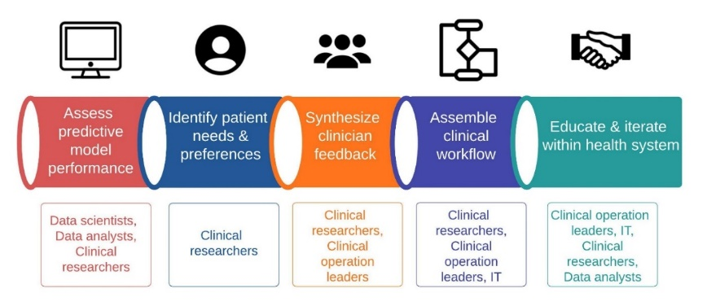  ML implementation pathway for suicide prevention. In each step, actions are summarized in the middle row and critical team members are listed in the bottom row. At KPNC, a predictive analytics core facilitates collaboration among data scientists, clinical researchers, data analysts, and health information technology (IT) specialists.  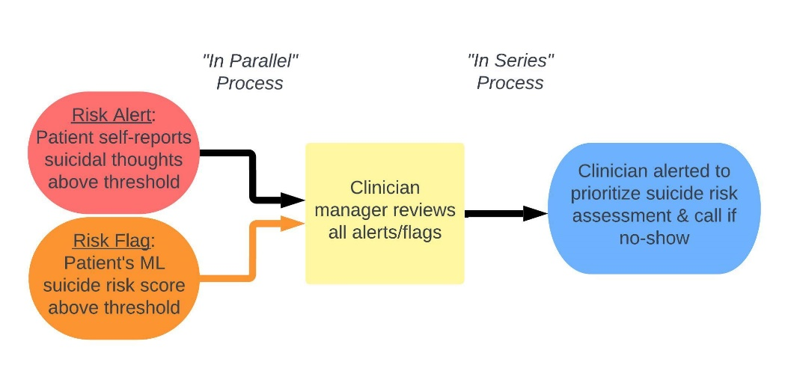  Clinical workflow. Black arrows indicate steps that were already in practice before ML implementation; the orange arrow indicates the new step adopted into the workflow. ML suicide risk score flags for incoming intake visits would be presented to the C2C clinician manager, who would next alert the patient’s intake clinician to conduct a prioritized suicide risk assessment at the scheduled outpatient visit. If a patient no-showed to the visit, the intake clinician would outreach by phone contact for a suicide risk assessment.  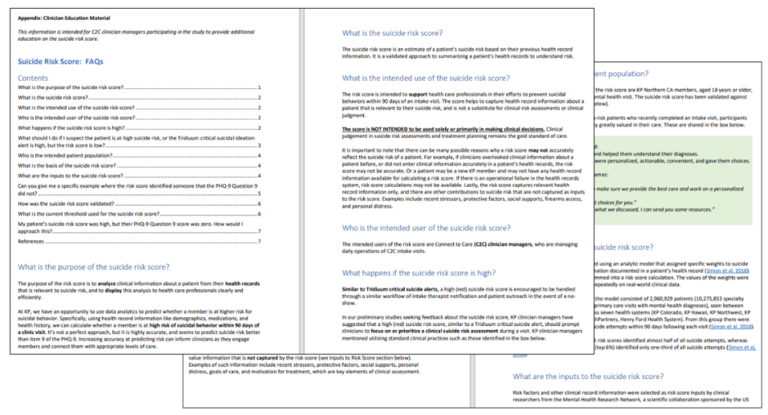  Clinician education materials. Sample pages from the clinician education handbook. The handbook followed guidelines for user-facing information as outlined in the United States Food and Administration (FDA) September 2022 Guidance for Clinical Decision Support Software.²³ Additional information requested by clinicians to be included were (a) discussion of pertinent clinical information not captured by the suicide risk score, including examples where a patient may be at elevated suicide risk despite a low score, (b) anonymized case examples of two patients with elevated suicide risk scores but denied suicidal thoughts at the visit, to illustrate how a patient’s EHR variables can contribute to their calculated risk.

