Delivery Science Grants Program
Use of and outcomes related to intrapleural fibrinolytic therapy for complicated parapneumonic effusion and empyema in an integrated health system Eduardo Solbes MD, Khanh K Thai MS, Patricia Kipnis PhD, Kathleen A. Daly BS, Lori C. Sakoda PhD, MPH, Jeffrey B. Velotta MD, Vincent X. Liu MD MS, Laura C. Myers MD MPH
Project start and end dates: July 2023-July 2025
Challenge | As a health system, operationally we are currently not delivering MIST-2 dosing of intrapleural medications for complicated parapneumonic effusion/empyema in an evidence-based way. We sought to examine outcomes related to dosing in order to inform operations.
Existing Evidence | The MIST2 trial is the best existing evidence for managing complicated parapneumonic pleural effusion of empyema. This randomized controlled trial showed that a regimen of twice daily administration of 2 medications (TPA/DORNASE) into a pleural catheter for 3 days decreased patients’ likelihood of needing surgical intervention (decortication and wash out). However, in many hospitals, we do not have the operational capability of twice daily administration of this medication because pulmonary specialists are typically the one administering it into the chest tube. In this study, we aimed to review outcomes of patients within the KPNC health system who did and did not receive this regimen in order to inform whether we change operational practice, i.e., allow other providers available 24hr daily to administer the medication or administer it at specific time intervals (7a and 4p) that are closer together than 12 hours or staff pulmonary physicians in the later evening hours.
Target Population | Adults hospitalized within the 21 hospitals of KPNC (age ≥18 years old) between 2015-2023. To identify patients with complicated parapneumonic pleural effusion or empyema, we leveraged our detailed electronic health record and found patients who received: 1) tube thoracostomy (identified by procedure note with corresponding flow sheet entries), 2) at least 1 standard dose of alteplase and dornase administered together via intrapleural route, and 3) antibiotics for at least 48 hours during the hospitalization.
Intervention or Exposure | The primary exposure was dosing of IPFT that was consistent with the regimen used in the MIST-2 trial (“MIST-2-concordant dosing”).² We chose to study the MIST-2 dosing regimen because it has been studied in the largest randomized clinical trial to date and is a widely accepted dosing regimen. Using real-world electronic health record medication administration data, we did serial chart reviews by physician co-authors (LCM and ES) in order to derive the best definition that fit “twice daily dosing for 3 days.” We ultimately defined MIST-2-concordant dosing as receiving exactly 6 standard doses of 10 mg of alteplase and 5 mg of dornase with 2 doses of both drugs being given in each 24-hour period for at least 2 consecutive days; we required that both medications be administered simultaneously.
Outcomes/Key Findings | The primary outcome was treatment escalation (defined as placement of a second concurrent chest tube from the line/drain/airway flow sheets or thoracic surgery during hospital admission from KPNC operative database) or bleeding (defined as acute blood loss anemia requiring transfusion of packed red blood cells after administration of at least 1 dose of IPFT or surgery for intrapleural hematoma evacuation). We ensured that the transfusion and surgical procedures occurred temporally after the administration of the first dose of IPFT. Other outcomes included inpatient length of stay and inpatient mortality.
Resulting Action/Change | We found that patients who received MIST-2 concordant dosing were less likely to need treatment escalation (additional chest tubes or thoracic surgery) and were not more likely to bleed. This is an important finding because as a health system, we should be grappling with how we operationalize these findings, i.e., in order to limit length of stay and optimize outcomes, how do we deliver MIST-2 concordant dosing when pulmonary providers are not routinely present in the hospital during evening hours? As a result of this study, we are actively engaging with pulmonary leadership to address this operational question.
Additional Recommendations | The solution here is not obvious or easy but we believe there are solutions that are resource neutral. For example, if we efficiently delivered the first dose at 7:30a then we could reasonably administer the second dose at 4:30p but this would need to be coordinated with pharmacy to provide the medication, which expires within a certain time period of being drawn up. We believe standardizing the administration could improve patient outcomes.
Implementation Tools | We have not implemented change yet, but these results have sparked discussion in the operational world in the pulmonary specialty to try to come up with the best solution (balancing outcomes and cost).
Implementation Measurement | As above, we have not implemented a change yet.
Reference | Figure 1. Variation in administration of MIST-2-concordant intrapleural fibrinolytic therapy  Legend: This figure visualizes the facility-level variation in the administration of MIST-2-concordant dosing of intrapleural fibrinolytic therapy. It shows the random facility effects from the mixed model that predicts MIST2 dosing as a function of the covariates described above and expressed as odds ratios.  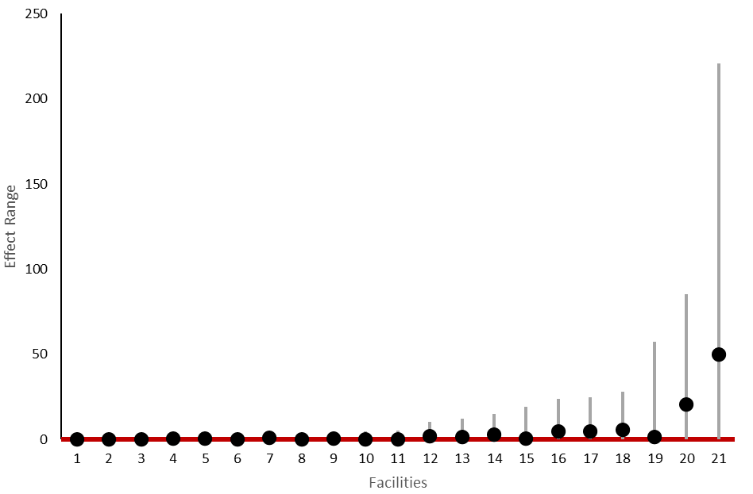  Table 1. Baseline characteristics of patients  ª COPS2 The COmorbidity Point Score, version 2 (COPS2, range, 0 to 1010, higher scores indicate increasing comorbidity burden) is assigned based on all diagnoses incurred by a patient in the 12 months preceding the index hospitalization. The univariate relationship of COPS2 with 30-day mortality is as follows: 0-39, 1.7%; 40-64, 5.2%; 65+, 9.0%.¹⁰  ^{b} LAPS2 The Laboratory-based Acute Physiology Score, version 2 (LAPS2, range, 0 to 414, higher scores indicating increasing physiologic derangement) is assigned based on a patient’s worst vital signs, pulse oximetry, neurological status, and 16 laboratory test results in the preceding 24 (hourly and discharge LAPS2) or 72 hours (admission LAPS2). The univariate relationship of an admission LAPS2 with 30-day mortality is as follows: 0-59, 1.0%; 60-109, 5.0%; 110+, 13.7%.¹⁰  Table 2. Outcomes related to dosing of intrapleural thrombolytic therapy where the exposure is MIST-2-concordant dosing  HR=Hazard Ratio  References  1. Semenkovich TR, Olsen MA, Puri V, Meyers BF, Kozower BD. Current State of Empyema Management. Ann Thorac Surg. Jun 2018;105(6):1589-1596. doi:10.1016/j.athoracsur.2018.02.027  2. Rahman NM, Maskell NA, West A, et al. Intrapleural use of tissue plasminogen activator and DNase in pleural infection. N Engl J Med. Aug 11 2011;365(6):518-26. doi:10.1056/NEJMoa1012740  3. Light RW. Parapneumonic effusions and empyema. Proc Am Thorac Soc. 2006;3(1):75-80. doi:10.1513/pats.200510-113JH  4. Farjah F, Symons RG, Krishnadasan B, Wood DE, Flum DR. Management of pleural space infections: a population-based analysis. J Thorac Cardiovasc Surg. Feb 2007;133(2):346-51. doi:10.1016/j.jtcvs.2006.09.038  5. Chong WH, Saha BK, Conuel E, Chopra A. The incidence of pleural effusion in COVID-19 pneumonia: State-of-the-art review. Heart Lung. Jul-Aug 2021;50(4):481-490. doi:10.1016/j.hrtlng.2021.02.015  6. Jiang C, Xie M, Cervellione K, Thurm C. Clinical efficacy and bleeding outcomes of tissue plasminogen activator and dornase alfa in pleural space infection with once daily concurrent administration: a retrospective cohort study. BMC Res Notes. Aug 3 2020;13(1):368. doi:10.1186/s13104-020-05210-2  7. Majid A, Kheir F, Folch A, et al. Concurrent Intrapleural Instillation of Tissue Plasminogen Activator and DNase for Pleural Infection. A Single-Center Experience. Ann Am Thorac Soc. Sep 2016;13(9):1512-8. doi:10.1513/AnnalsATS.201602-127OC  8. Akulian J, Bedawi EO, Abbas H, et al. Bleeding Risk With Combination Intrapleural Fibrinolytic and Enzyme Therapy in Pleural Infection: An International, Multicenter, Retrospective Cohort Study. Chest. Dec 2022;162(6):1384-1392. doi:10.1016/j.chest.2022.06.008  9. Davis AC, Voelkel JL, Remmers CL, Adams JL, McGlynn EA. Comparing Kaiser Permanente Members to the General Population: Implications for Generalizability of Research. Perm J. Jun 15 2023;27(2):87-98. doi:10.7812/TPP/22.172  10. Escobar GJ, Gardner MN, Greene JD, Draper D, Kipnis P. Risk-adjusting hospital mortality using a comprehensive electronic record in an integrated health care delivery system. Med Care. May 2013;51(5):446-53. doi:10.1097/MLR.0b013e3182881c8e  11. Stroup WW. Generalized Linear Mixed Models: Modern Concepts, Methods and Applications. Taylor & Francis; 2012.  12. Lau EPM, Eshraghi M, Dootson K, et al. An international survey on the use of intrapleural tissue plasminogen activator/DNase therapy for pleural infection. ERJ Open Res. Jan 2022;8(1)doi:10.1183/23120541.00590-2021  13. Patrini D, Panagiotopoulos N, Pararajasingham J, Gvinianidze L, Iqbal Y, Lawrence DR. Etiology and management of spontaneous haemothorax. J Thorac Dis. Mar 2015;7(3):520-6. doi:10.3978/j.issn.2072-1439.2014.12.50  14. Majid A, Ochoa S, Chatterji S, et al. Safety and Efficacy of Tissue Plasminogen Activator and DNase for Complicated Pleural Effusions Secondary to Abdominal Pathology. Ann Am Thorac Soc. Mar 2017;14(3):342-346. doi:10.1513/AnnalsATS.201608-594BC  15. Maskell NA, Davies CW, Nunn AJ, et al. U.K. Controlled trial of intrapleural streptokinase for pleural infection. N Engl J Med. Mar 3 2005;352(9):865-74. doi:10.1056/NEJMoa042473  16. Patino SH, Tarrazzi F, Tami C, Bellini A, Block M. Extended Dwell Time Improves Results of Fibrinolytic Therapy for Complex Pleural Effusions. Cureus. Aug 11 2020;12(8):e9664. doi:10.7759/cureus.9664  17. Popowicz N, Bintcliffe O, De Fonseka D, et al. Dose De-escalation of Intrapleural Tissue Plasminogen Activator Therapy for Pleural Infection. The Alteplase Dose Assessment for Pleural Infection Therapy Project. Ann Am Thorac Soc. Jun 2017;14(6):929-936. doi:10.1513/AnnalsATS.201609-673OC  18. Davis AC, Voelkel JL, Remmers CL, Adams JL, McGlynn EA. Comparing Kaiser Permanente Members to the General Population: Implications for Generalizability of Research. Perm J. May 12 2023:1-12. doi:10.7812/TPP/22.172  19. Bedawi EO, Stavroulias D, Hedley E, et al. Early Video-assisted Thoracoscopic Surgery or Intrapleural Enzyme Therapy in Pleural Infection: A Feasibility Randomized Controlled Trial. The Third Multicenter Intrapleural Sepsis Trial-MIST-3. Am J Respir Crit Care Med. Dec 15 2023;208(12):1305-1315. doi:10.1164/rccm.202305-0854OC
  Characteristic | All Patients | Received MIST-2 | Not  MIST-2 | P Value
  N | N = 1,751 | N = 99 | N = 1,652
  Age | 67.0 (55.0, 76.5) | 67.0 (50.5, 75.5) | 67.0 (55.0, 77.0) | 0.40
  Sex |  |  |  | 0.80
  Female | 630 (36.0%) | 37 (37.4%) | 593 (35.9%)
  Male | 1,121 (64.0%) | 62 (62.6%) | 1,059 (64.1%)
  COPS2ª at hospital entry time | 31.0 (10.0, 70.0) | 20.0 (10.0, 48.5) | 31.0 (10.0, 71.0) | 0.04
  LAPS2^{b} at hospital entry time | 89.0 (63.0, 119.0) | 96.0 (66.5, 120.0) | 89.0 (63.0, 119.0) | 0.30
  Supplemental oxygen before hospitalization | 162 (9.3%) | 5 (5.1%) | 157 (9.5%) | 0.14
  Intensive care unit admission from emergency department | 236 (13.5%) | 14 (14.1%) | 222 (13.4%) | 0.80
  Blood Culture Positive | 214 (12.2%) | 17 (17.2%) | 197 (11.9%) | 0.12
  Pleural Fluid Culture Positive | 538 (30.7%) | 41 (41.4%) | 497 (30.1%) | 0.02
  Time between hospital entry time and placement of Chest Tube | 0.9 (0.3, 3.0) | 0.7 (0.0, 1.8) | 1.0 (0.4, 3.0) | 0.006
  Non-metastatic solid cancer | 308 (17.6%) | 20 (20.2%) | 288 (17.4%) | 0.50
  Metastatic solid cancer | 186 (10.6%) | 10 (10.1%) | 176 (10.7%) | 0.90
  Lymphoma | 43 (2.5%) | 2 (2.0%) | 41 (2.5%) | >0.9
  Immunocompromised status (based on diagnosis codes or immunosuppressants/chemotherapy) | 101 (5.8%) | 5 (5.1%) | 96 (5.8%) | 0.80
  Filled anticoagulation prescription in 1 year prior | 275 (15.7%) | 11 (11.1%) | 264 (16.0%) | 0.20
  Underwent thoracic surgery in 1 year prior | 50 (2.9%) | 3 (3.0%) | 47 (2.8%) | 0.80
  Outcome | Effect Estimate | 95% Confidence Interval | P Value
  Primary analysis  Treatment escalation or bleeding (accounting for death as competing risk) | HR 0.61 | 95% CI 0.43, 0.88 | P=0.009
  Length of stay, days | 2.01 days shorter (15% reduction) | 95% CI 5%-23% | P=0.003
  Mortality | HR 0.60 | 95% CI 0.17-2.06 | P=0.41
  Treatment escalation alone | HR 0.64 | 95% CI 0.41, 0.99 | P=0.04

